CASTLES
& Mansion Houses of the
HOUSE OF FORBES
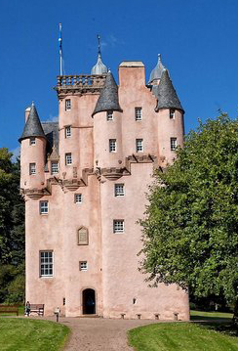

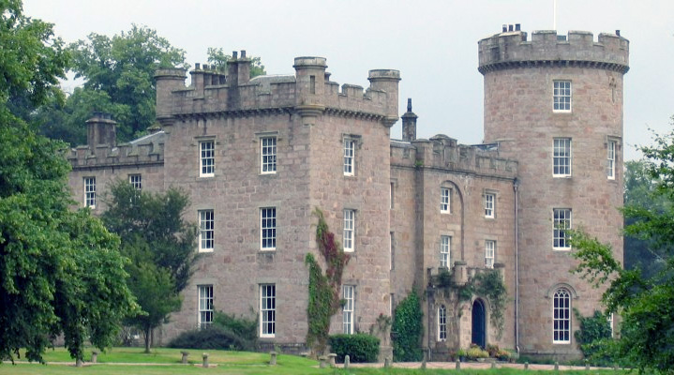

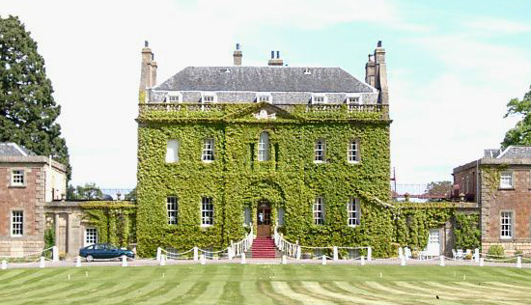
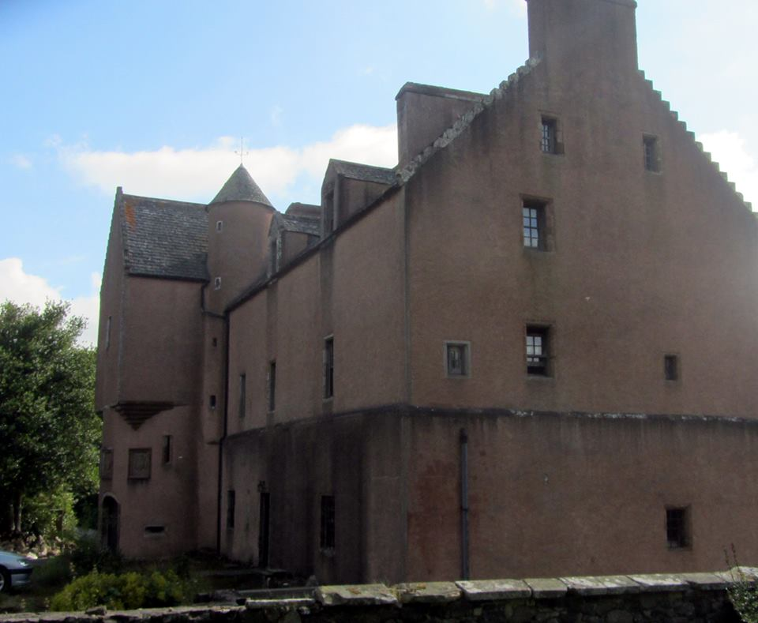

CASTLES
& Mansion Houses of the
HOUSE OF FORBES

Publication of

Clan Forbes Society, Inc.

Clan-Forbes.org
@ClanForbesSociety

Table of Contents

Introduction, Malcolm, Lord Forbes 4
House of Forbes 5
Druminnor Castle, Original Castle Forbes 6
Castle Forbes 9
Callendar House 15
Corgarff Castle 18
Corse Castle 20
Craigievar Castle 23
Culloden House 26
Ellon Castle 28
Pitsligo Castle & Kirks 29
Thainstone House 34
Tolquhon Castle 36
Plan Your Visit 38
Acknowledgements 39

Introduction

House of Forbes
The House of Forbes is a family originating in the area now known as Aberdeenshire, Scotland. The name Forbes is most probably a location name assumed from the lands of Forbes in Aberdeenshire, in possession of this family reputedly since the time of King William the Lion. While there are many legends surrounding the origins of this clan historians write the Forbes are descendants from Kings of the Picts. Oconachar, founder of the clan, claimed the land as "first occupier". The present chief still holds part of the Lordship of these Forbes lands. The first person on record was Duncan Forbes who in 1271–2 received a grant of lands from Alexander III of Scotland.
The hereditary leader of the House of Forbes is Lord Forbes, the senior Lordship of Parliament in the Peerage of Scotland. The title was created sometime after 1436 for Alexander de Forbes, feudal baron of Forbes. The precise date of the creation is not known, but in a Precept dated July 12, 1442, he is already styled Lord Forbes. Brown's 1834 Peerage of Scotland gives a creation year of 1440. Malcolm, 23rd Lord Forbes, currently resides in Castle Forbes in Alford, Aberdeenshire. The members of the major branches of the House of Forbes have been associated with many castles and mansion houses in Scotland and abroad.

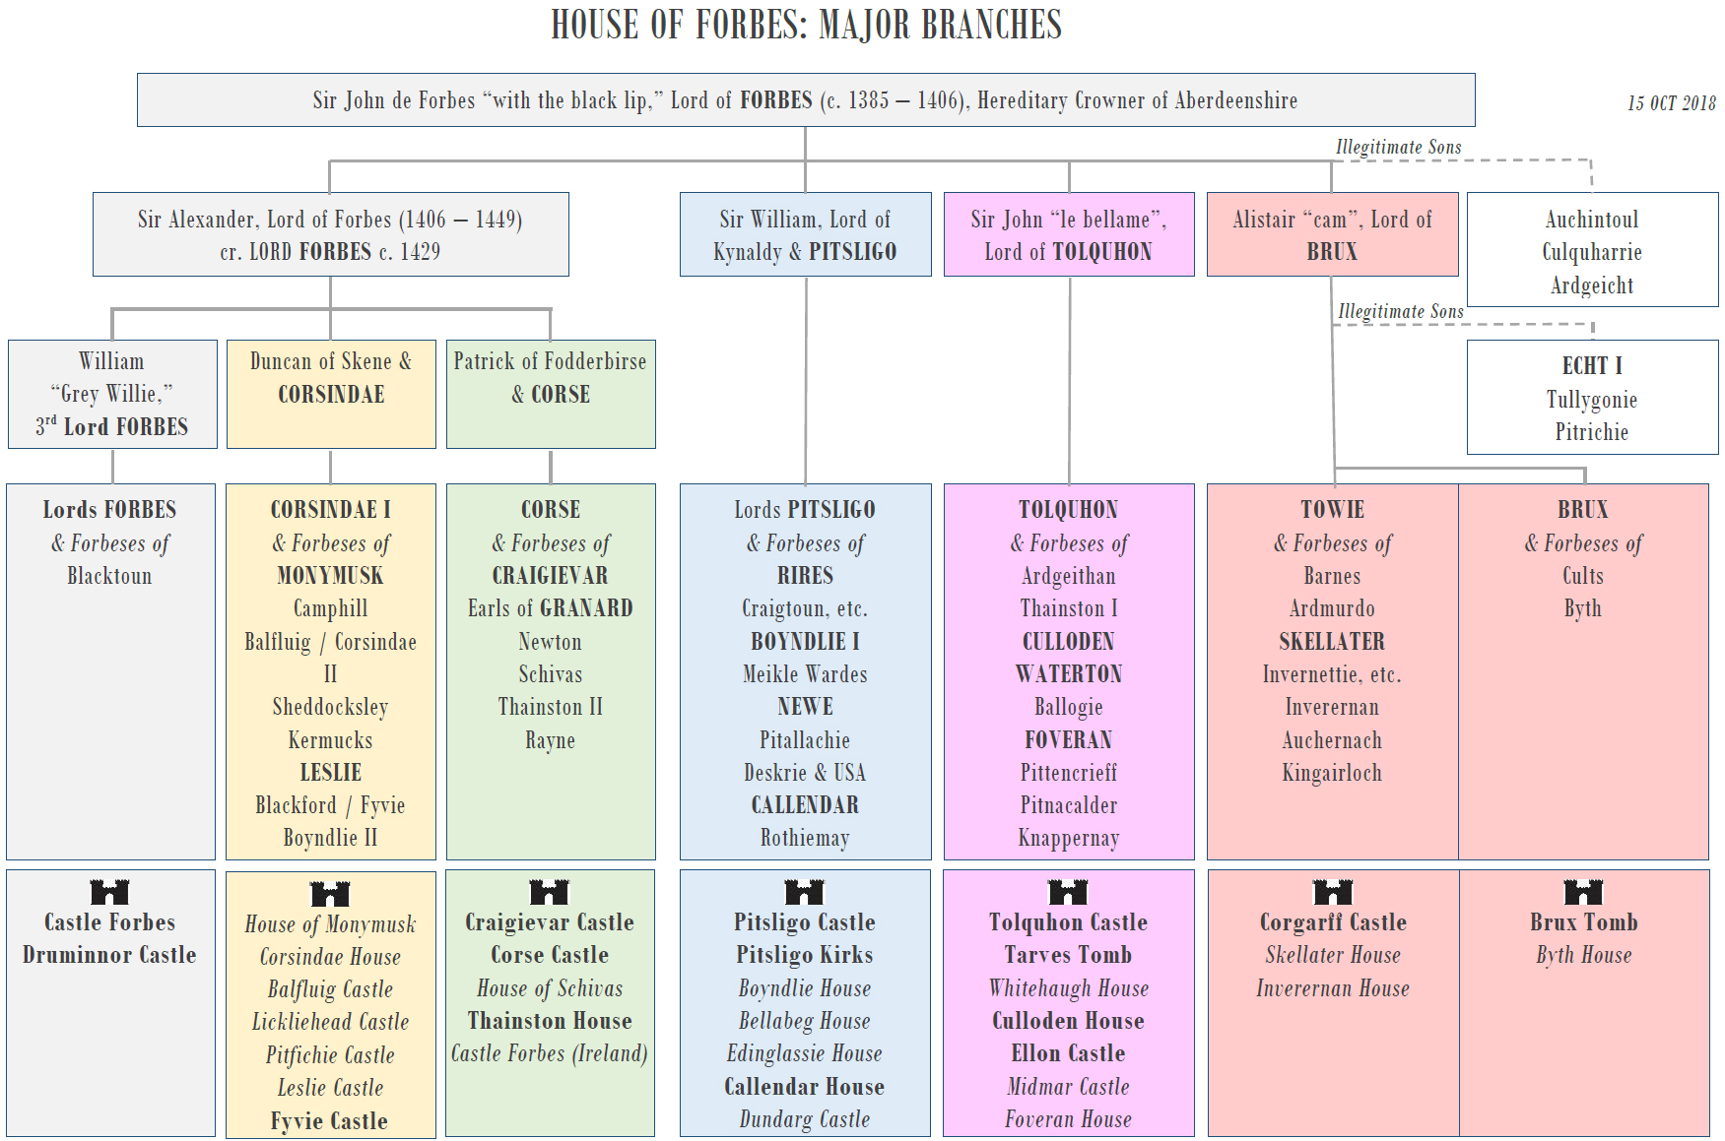
Note: Castles and mansion houses that are open to the public are noted in bold at the bottom of the chart. Private residences that are not open to the public are noted in italics.

Druminnor Castle, Original Castle Forbes
Location: Rhynie, Aberdeenshire, Scotland. Status: Open by Appointment.
Druminnor was the seat of the Chiefs of Clan Forbes for over 500 years until it was sold by the 16th Lord Forbes in 1770. Castle Forbes, as it was then called, was the stage for much of Forbes history. At its peak, the castle comprised two courtyards of buildings surrounded by a massive barmkyn (hillfort) wall, with a formal entrance forecourt to the west and extensive walled gardens to north and south. The 'Old Tower', enormously tall and famously 'dark', may have been built before 1300. In about 1430, Alexander 1st Lord Forbes added a large Hall block, the only part of the castle which has survived.
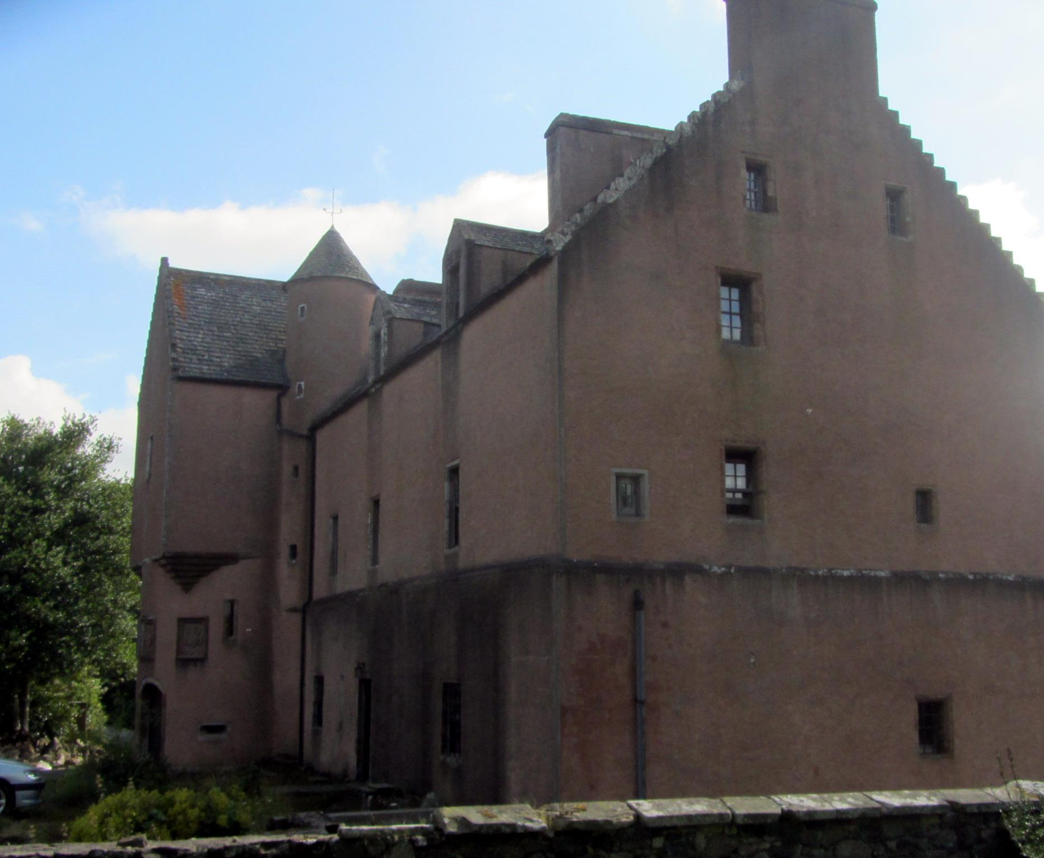

Over the next 580 years Castle Forbes was constantly changing: it was attacked by the Gordons in 1449, sacked by the Douglases in 1452, refortified in 1456, captured and partly demolished by the Gordons in 1571-3, substantially rebuilt in 1577, seized by the government in 1584, raided by Lord Forbes's sons in 1592, captured by Royalists and defended against Forbes attacks for two years in 1645-47, repaired and remodelled in 1660-61, frequently attacked by Jacobites in 1689-90, besieged by Jacobites in 1746, partly burned by accident in the 1750s.

The purchaser of Druminnor in 1770 was John Grant of Rothmaise. The Grants were lairds of Druminnor for six generations, until debt took them in their tum in 1955. The estates were split up: Druminnor House was bought by Margaret Forbes-Sempill, a daughter of Craigievar, restoring it to Forbes ownership after a gap of 185 years. In 1960-65 she demolished the 1841 additions and restored what was left of the old Forbes castle. In 1975 Druminnor was bought by Andrew Forbes of the Pitsligo & Monymusk branch. And so, while the Gordons left Huntly long ago, the Forbeses still possess their oldest stronghold, the chief chymmies of the duchus of Forbes.
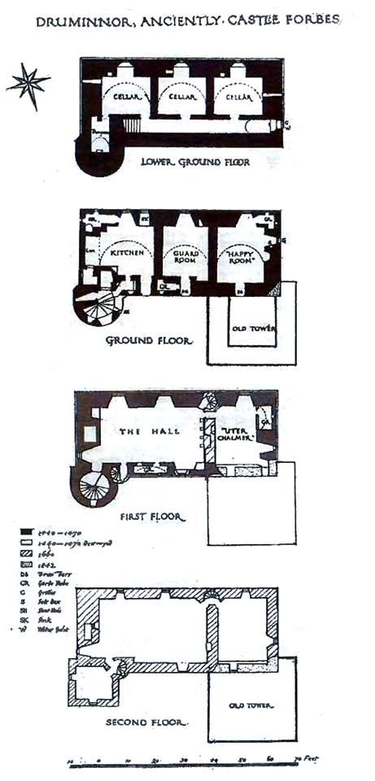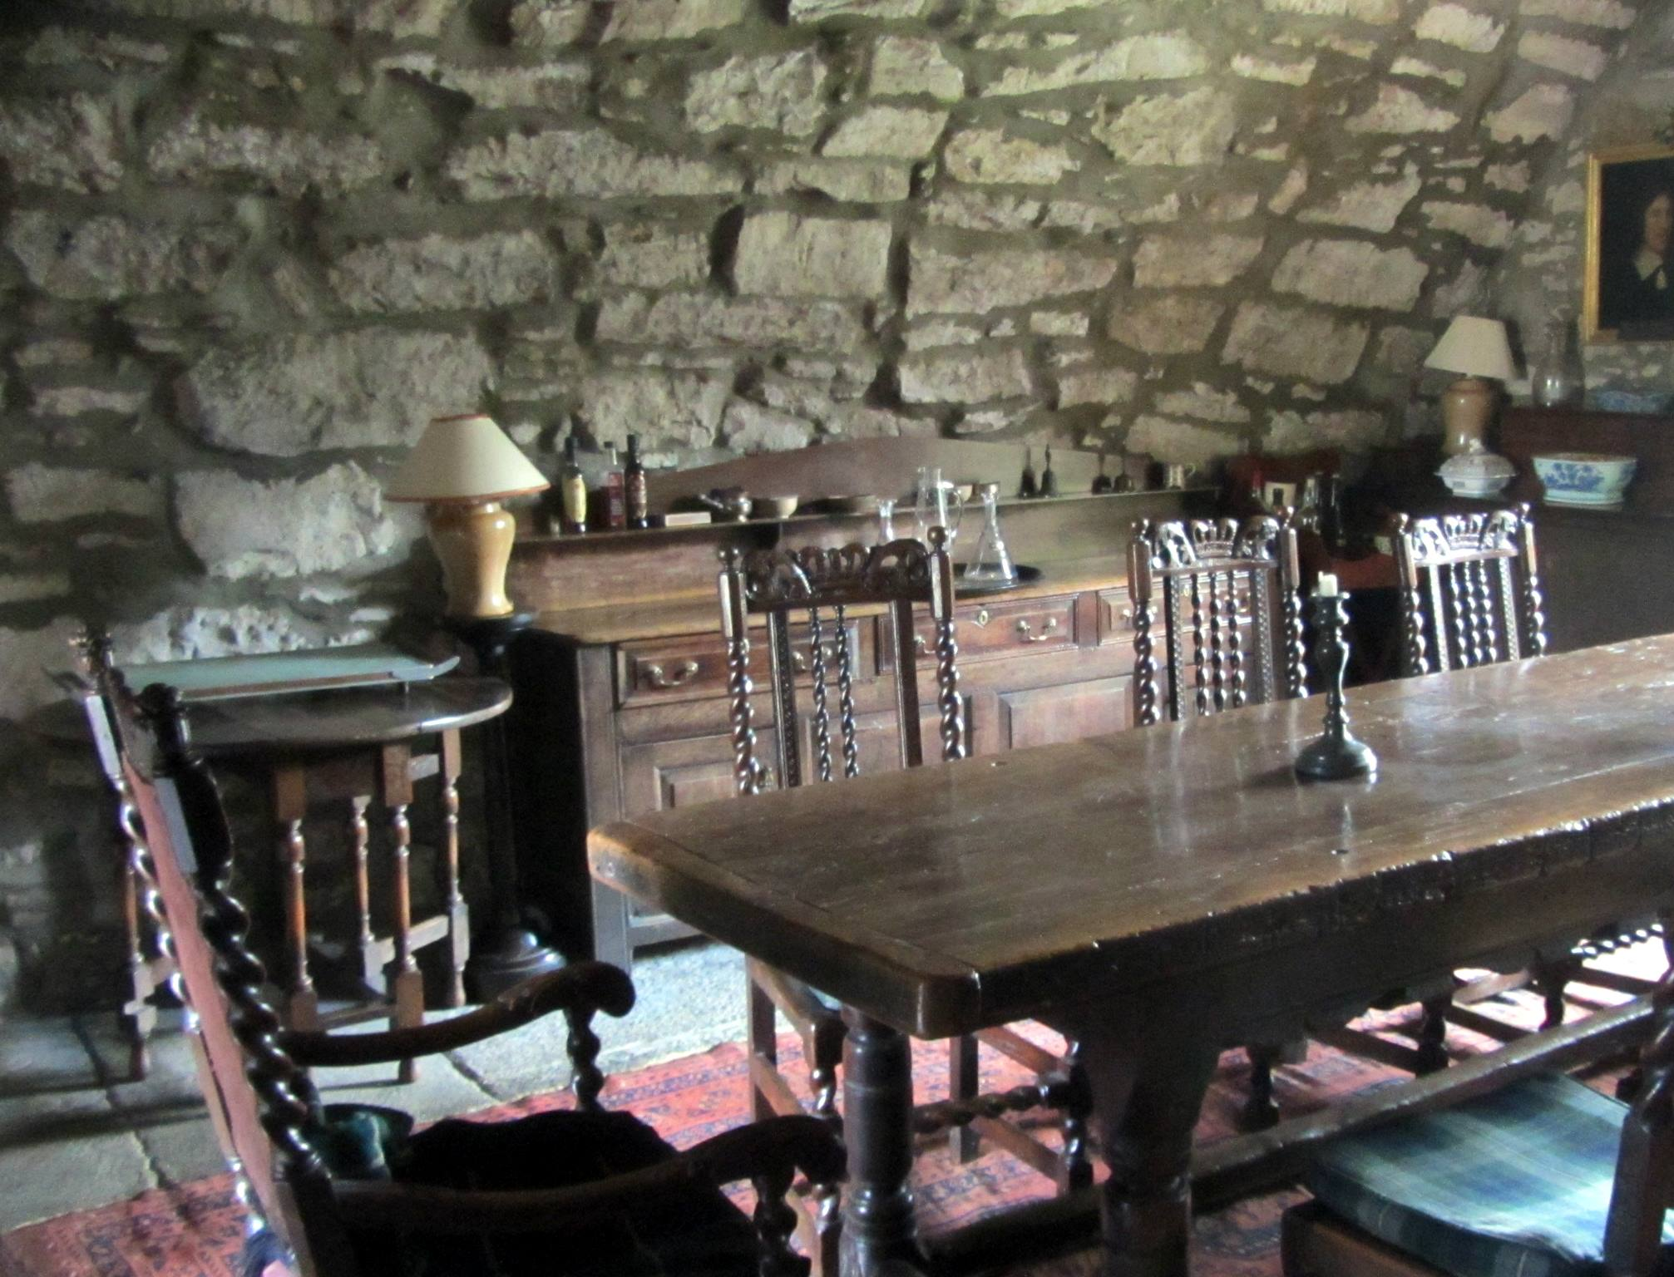
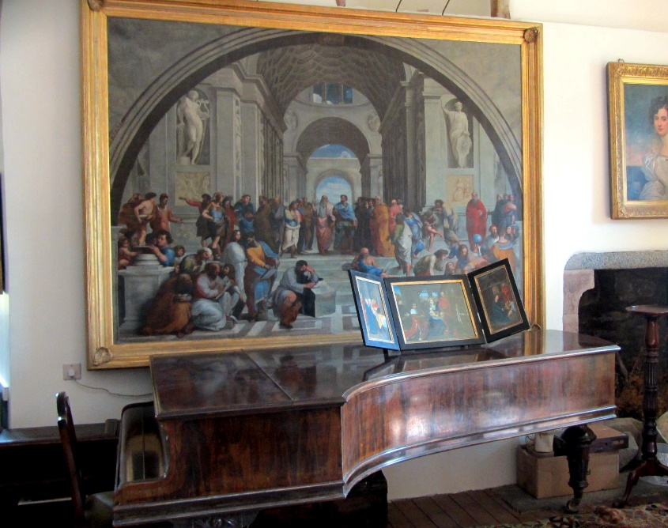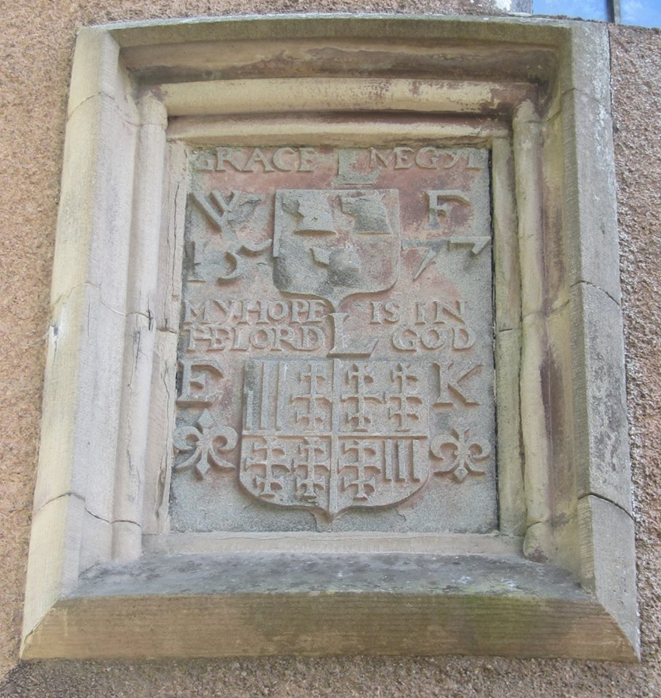
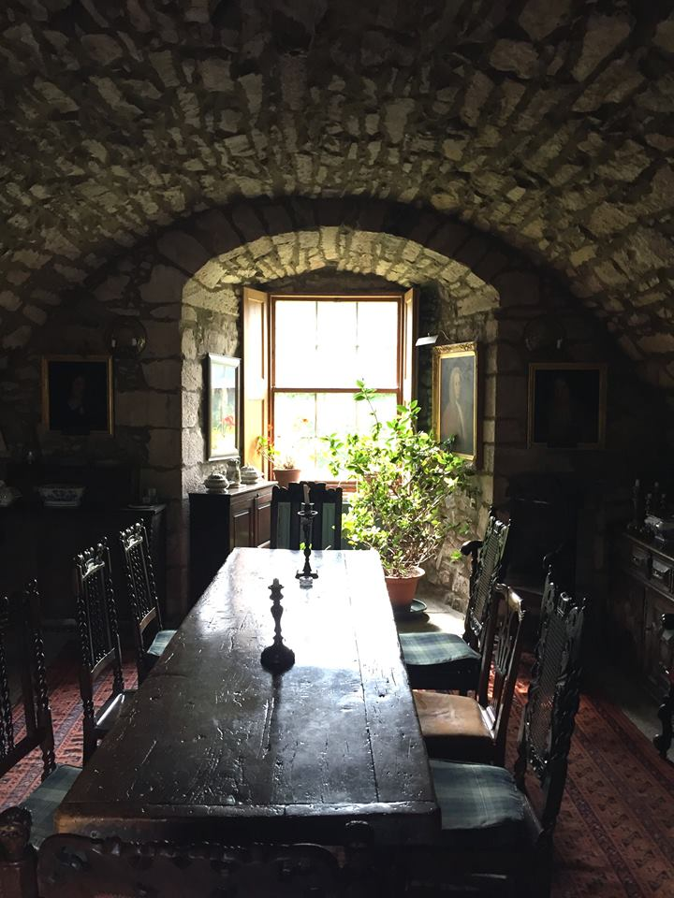
Castle Forbes
Location: Alford, Aberdeenshire, Scotland. Status: Open by appointment.
Castle Forbes is a 19th-century country house in the Scottish baronial architecture style near Alford in Aberdeenshire, Scotland. The 6,000 acres Castle Forbes Estate in Aberdeenshire is the seat of the Chief of the Forbes Clan. The lands were granted to Sir Alexander Forbes (later the 1st Lord Forbes) in 1411 for his part in the defeat of Donald of the Isles at the battle of Harlaw. Castle Forbes occupies a commanding position in parkland at the heart of the estate overlooking the river Don and the Howe of Alford with the hill of Bennachie behind. The original house was named Putachie.

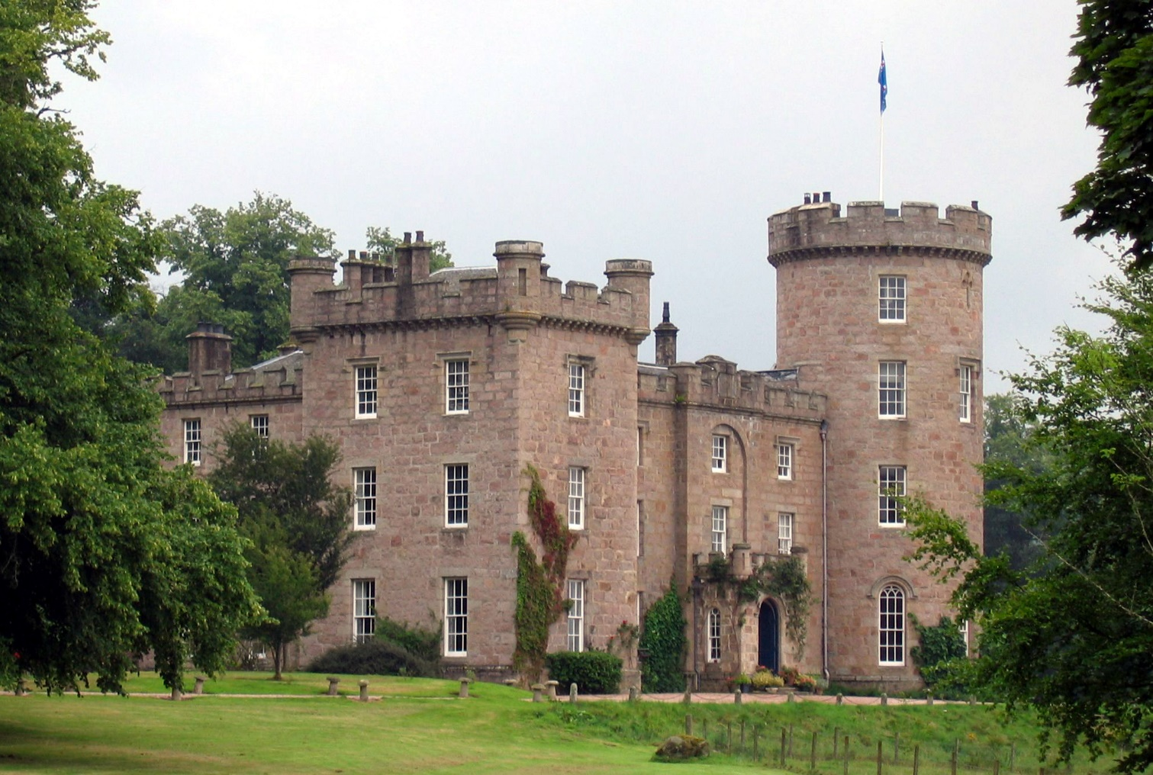

The present castle overlooking the River Don was built in 1815 by the 17th Lord Forbes, to designs by the architect Archibald Simpson. However, after Simpson encountered structural problems and the original section of the house (from c. 1731) began to crack, Simpson was dismissed and the work was completed by the City Architect of Aberdeen, John Smith. Today it is occupied by Malcolm Forbes, 23rd Lord Forbes (his father the 22nd Lord Forbes died 5 March 2013), and his wife Jinny and open to residential guests. The estate offers fishing and golf. In 1996, a former dairy building was converted into a small perfumery. A stone circle dating to 3000 BC is located on the estate.
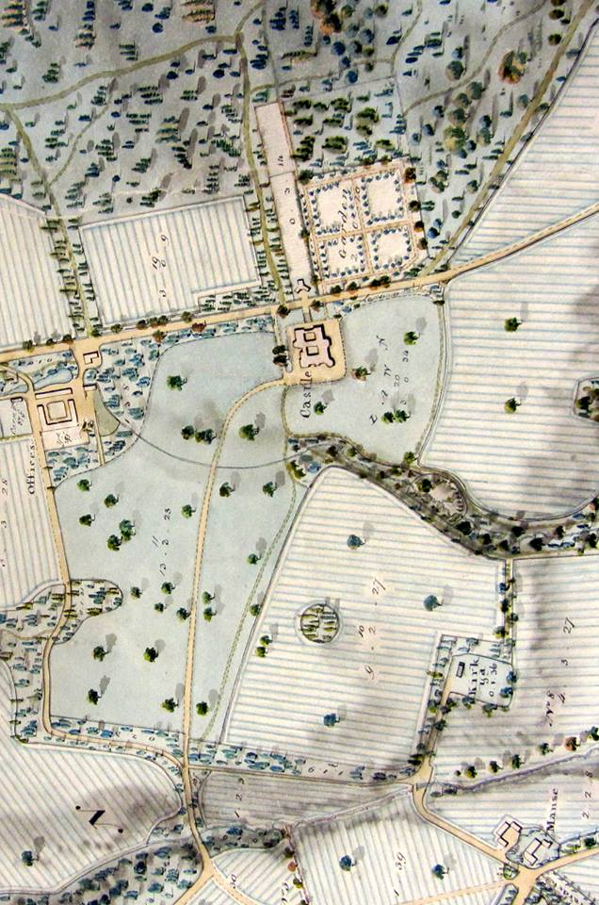

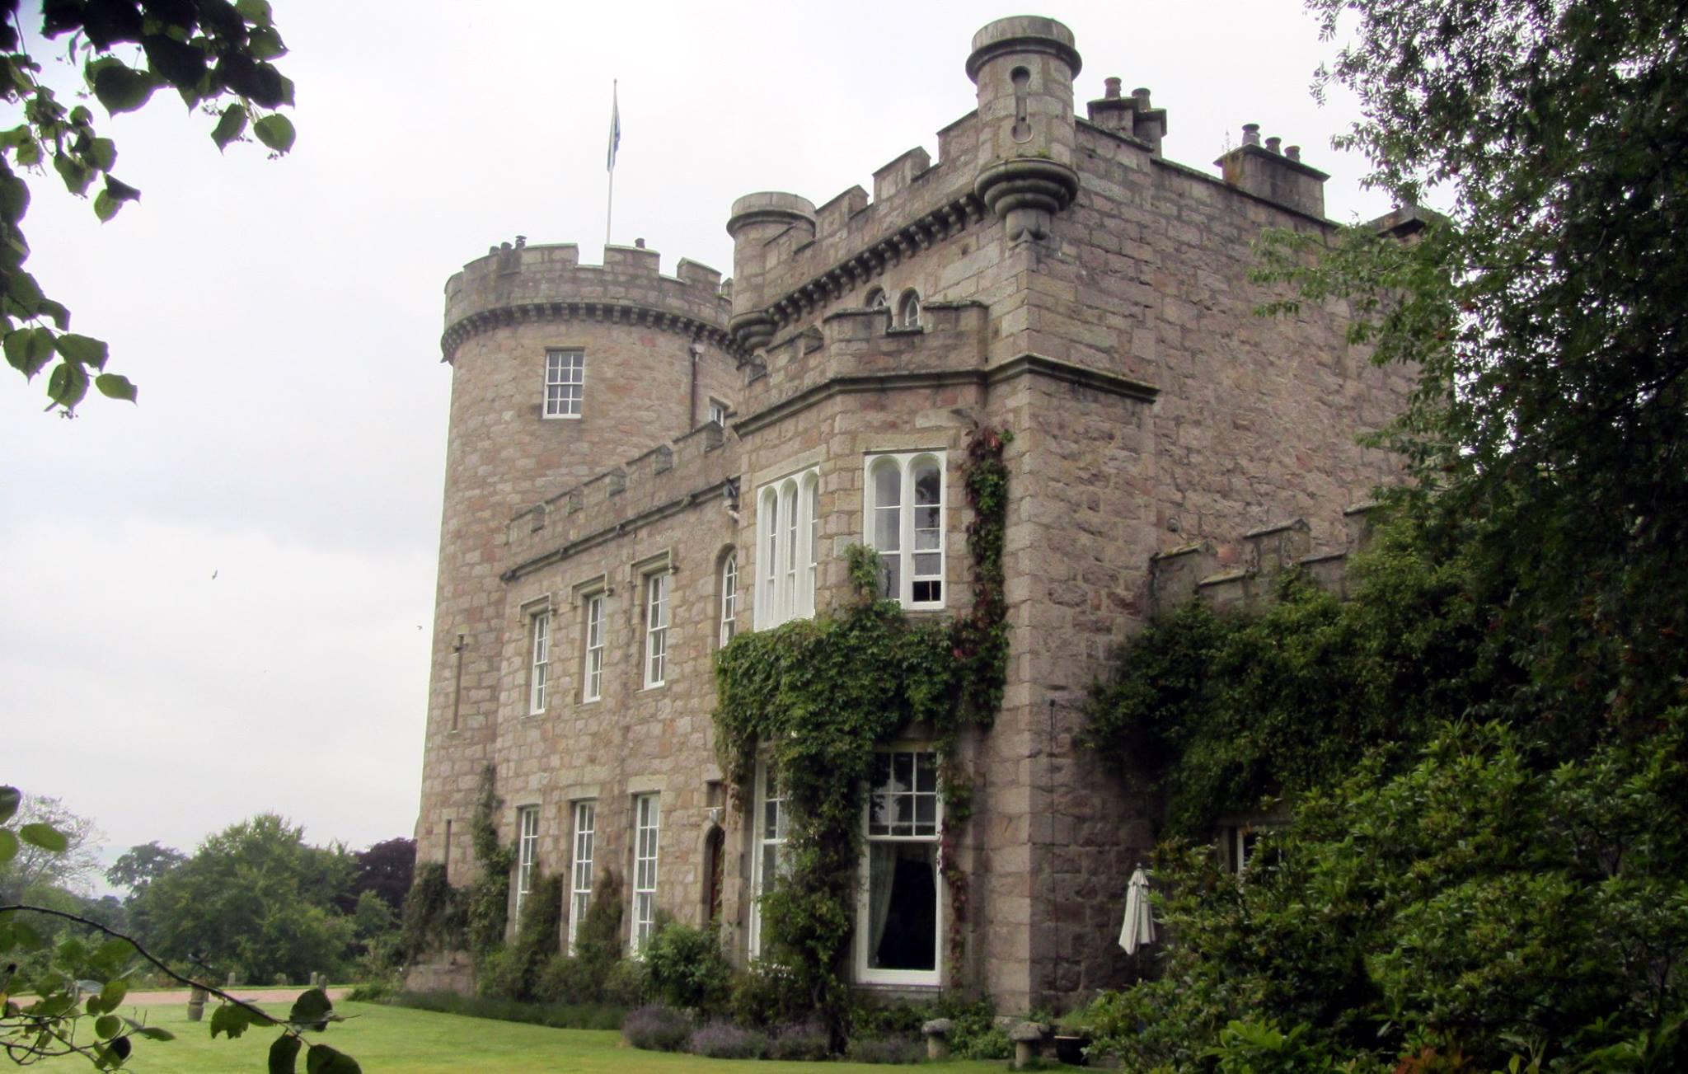
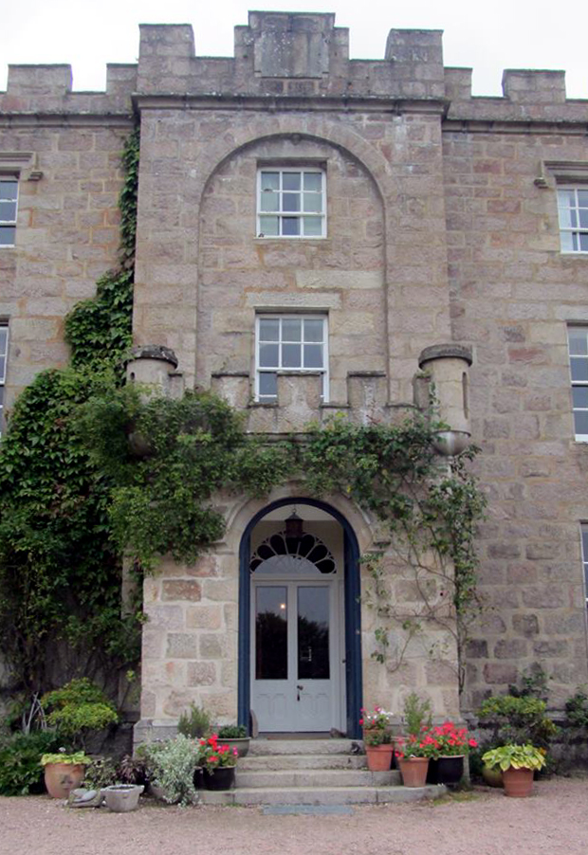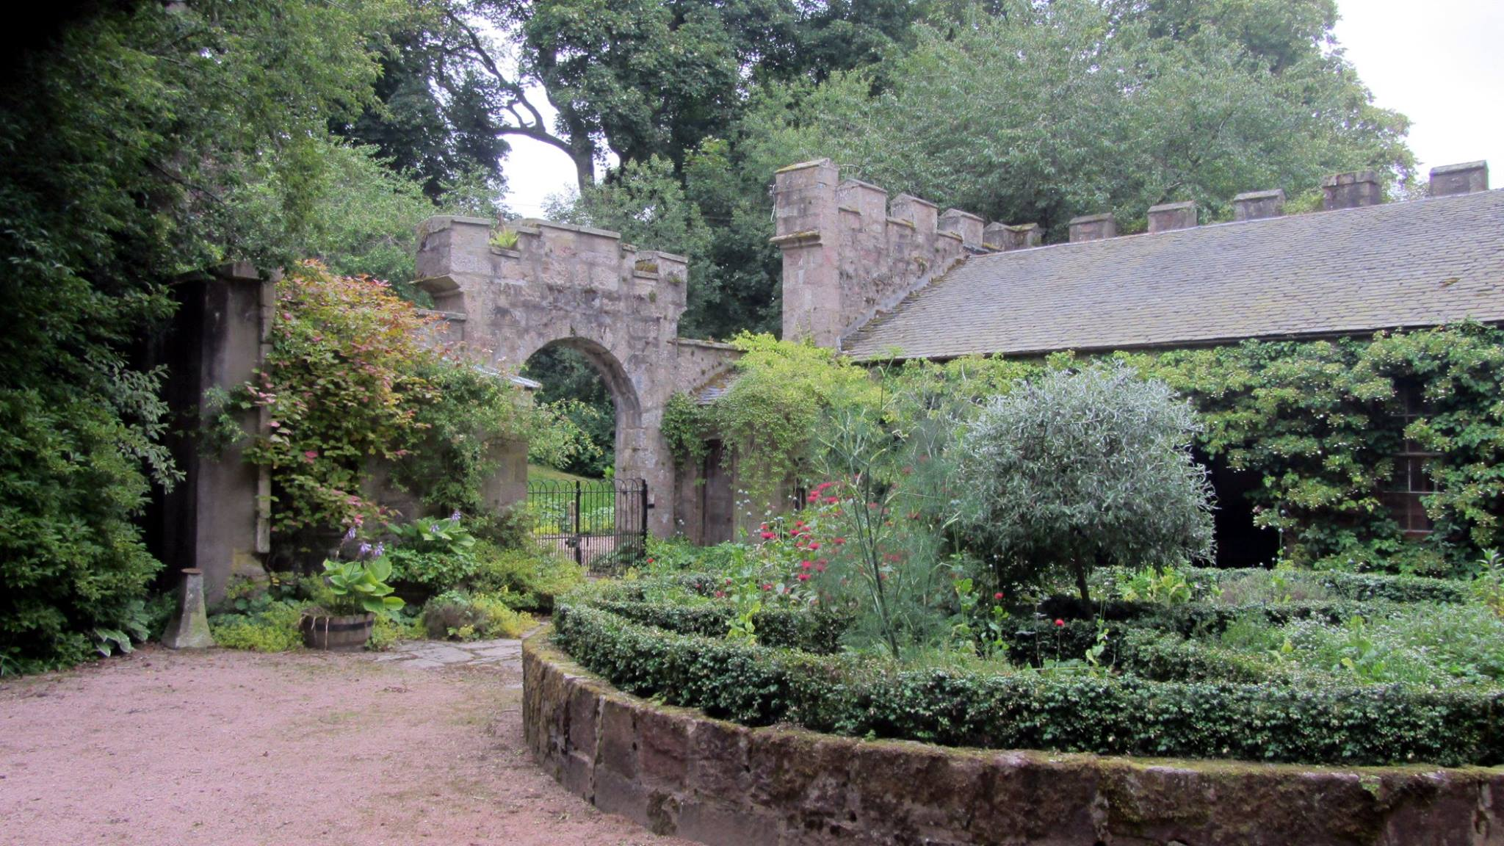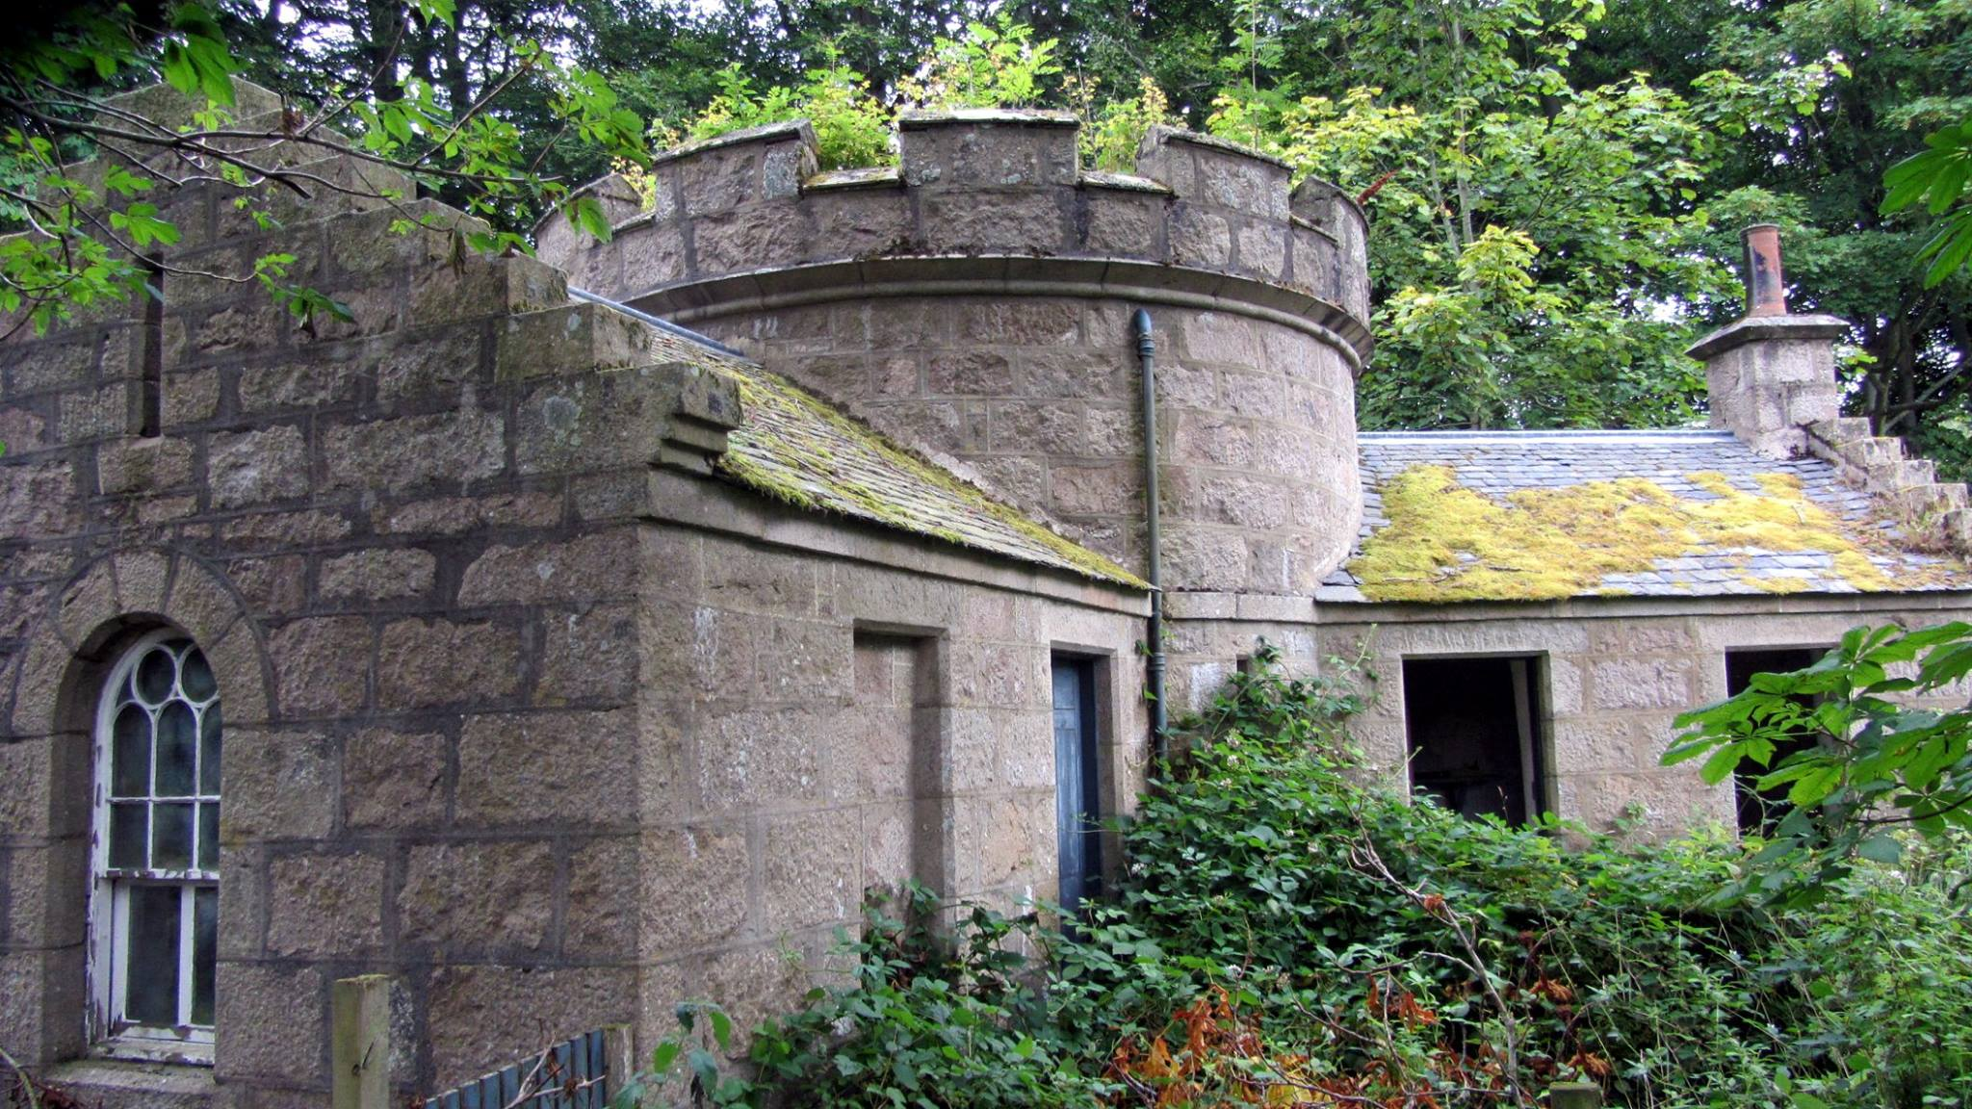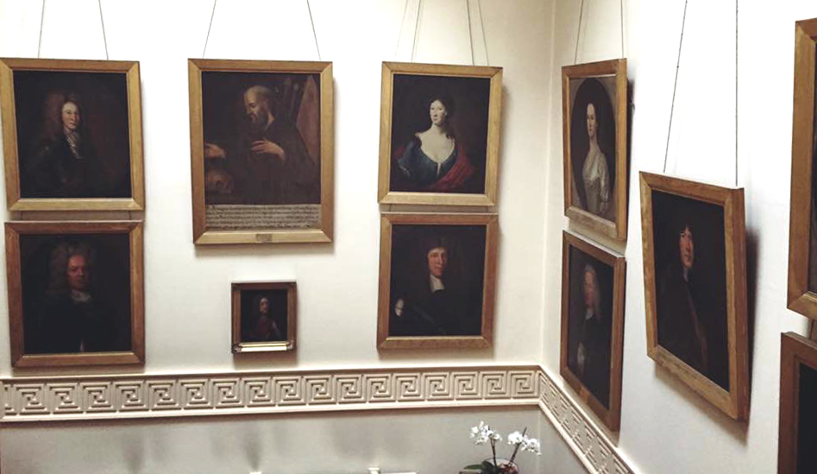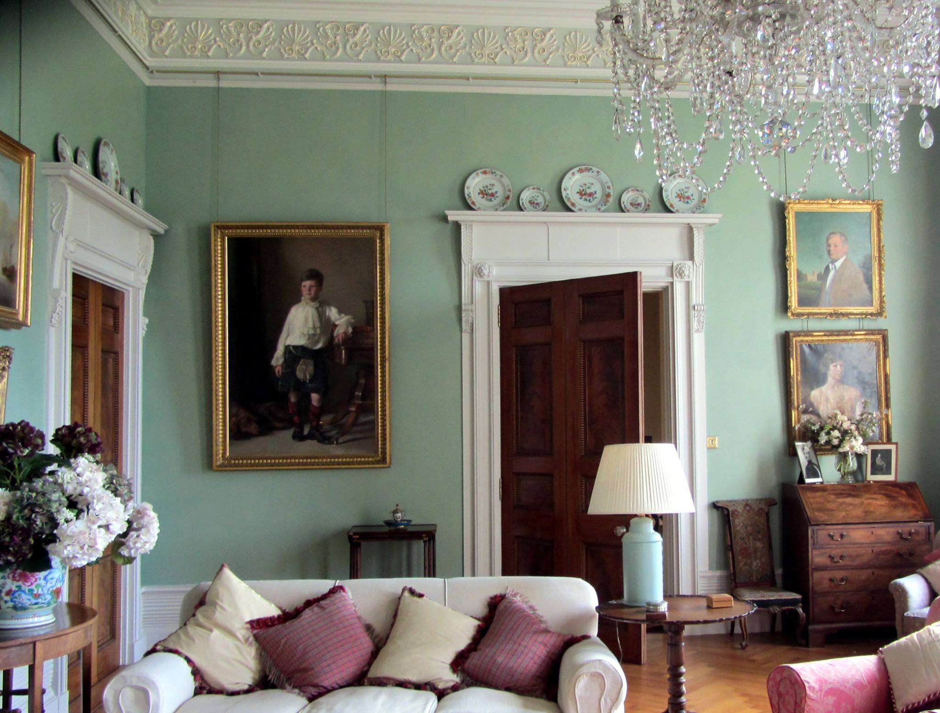
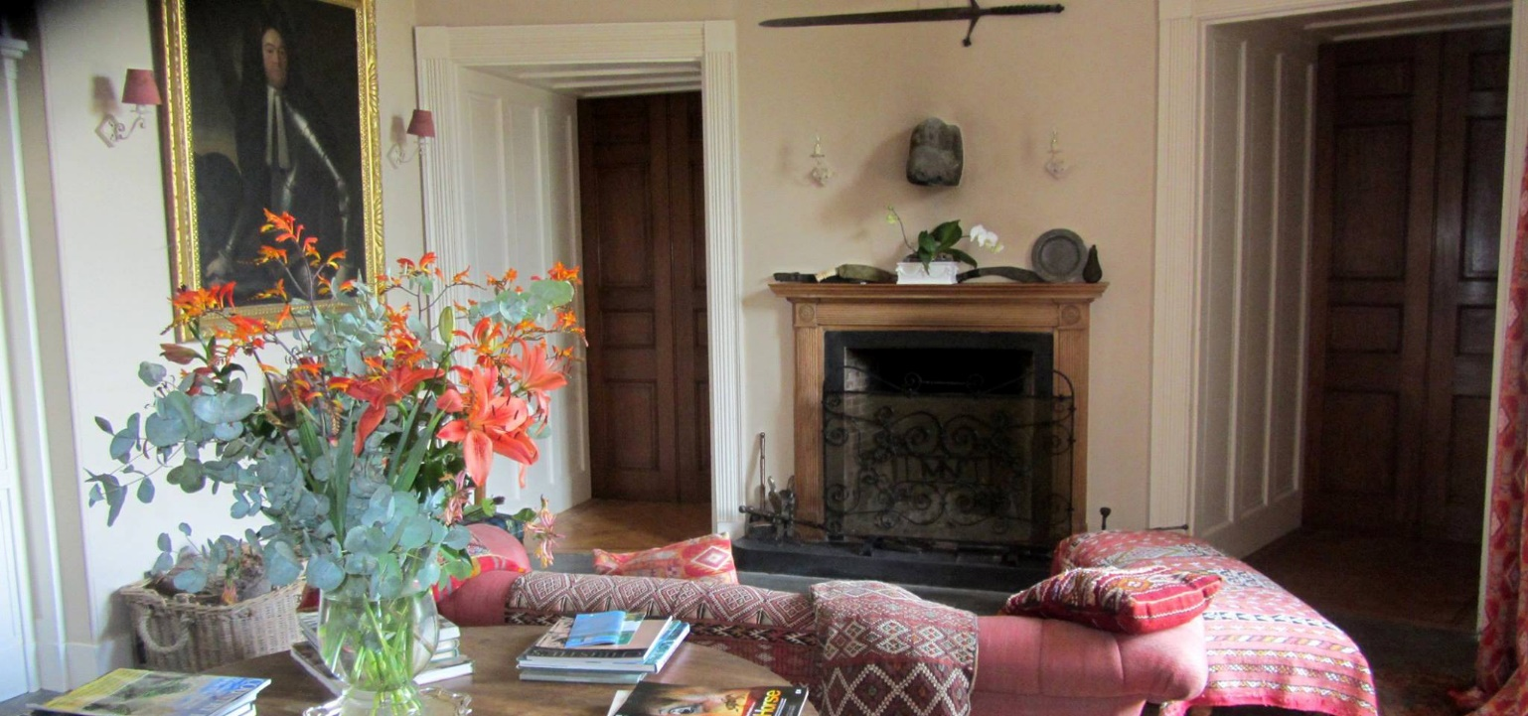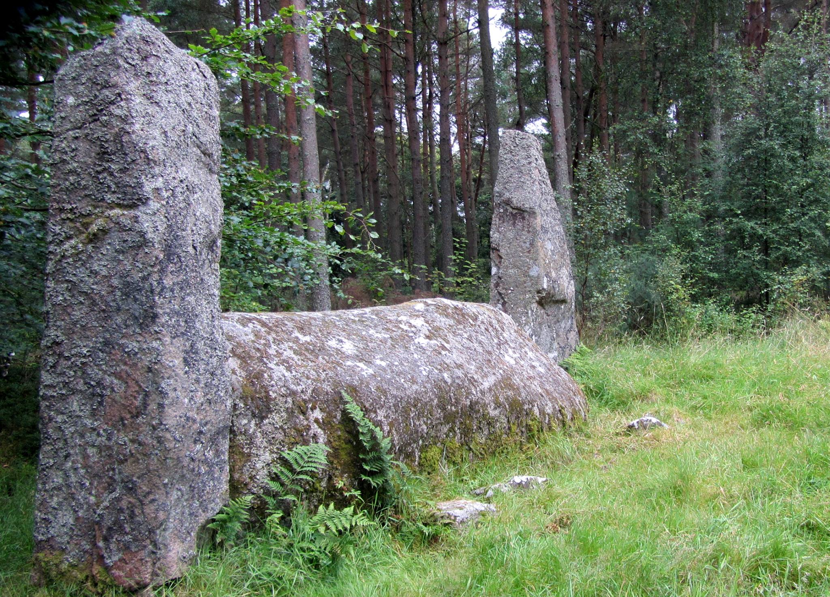

Callendar House
Location: Falkirk, Scotland. Status: Owned by Falkirk Community Trust.
Callendar House is a mansion set within the grounds of Callendar Park in Falkirk, central Scotland. During the 19th century, it was redesigned and extended in the style of a French Renaissance château fused with elements of Scottish baronial architecture. However, the core of the building is a 14th-century tower house. During its 600-year history, Callendar House has played host to many prominent historical figures, including Mary, Queen of Scots, Oliver Cromwell, Bonnie Prince Charlie and Queen Victoria. The current building is by far the most substantial historical building in the area, with a 300 ft (91 m) frontage. It is protected as a category A listed building, and the grounds are included in the Inventory of Gardens and Designed Landscapes in Scotland, the national listing of significant gardens.
The house lies on the line of the 2nd-century Antonine Wall, built by the Romans from the Firth of Clyde to the Firth of Forth. In the 12th century Thanes Hall or Thane House, located to the east of the present house, was one of the seats of the Callander family who were Thanes of Callander. In the fourteenth century the 5th Thane Sir Patrick Callander, supported the claim of Edward Balliol to the throne of Scotland. Sir Patrick Callander was later attainted and his estates were forfeited.

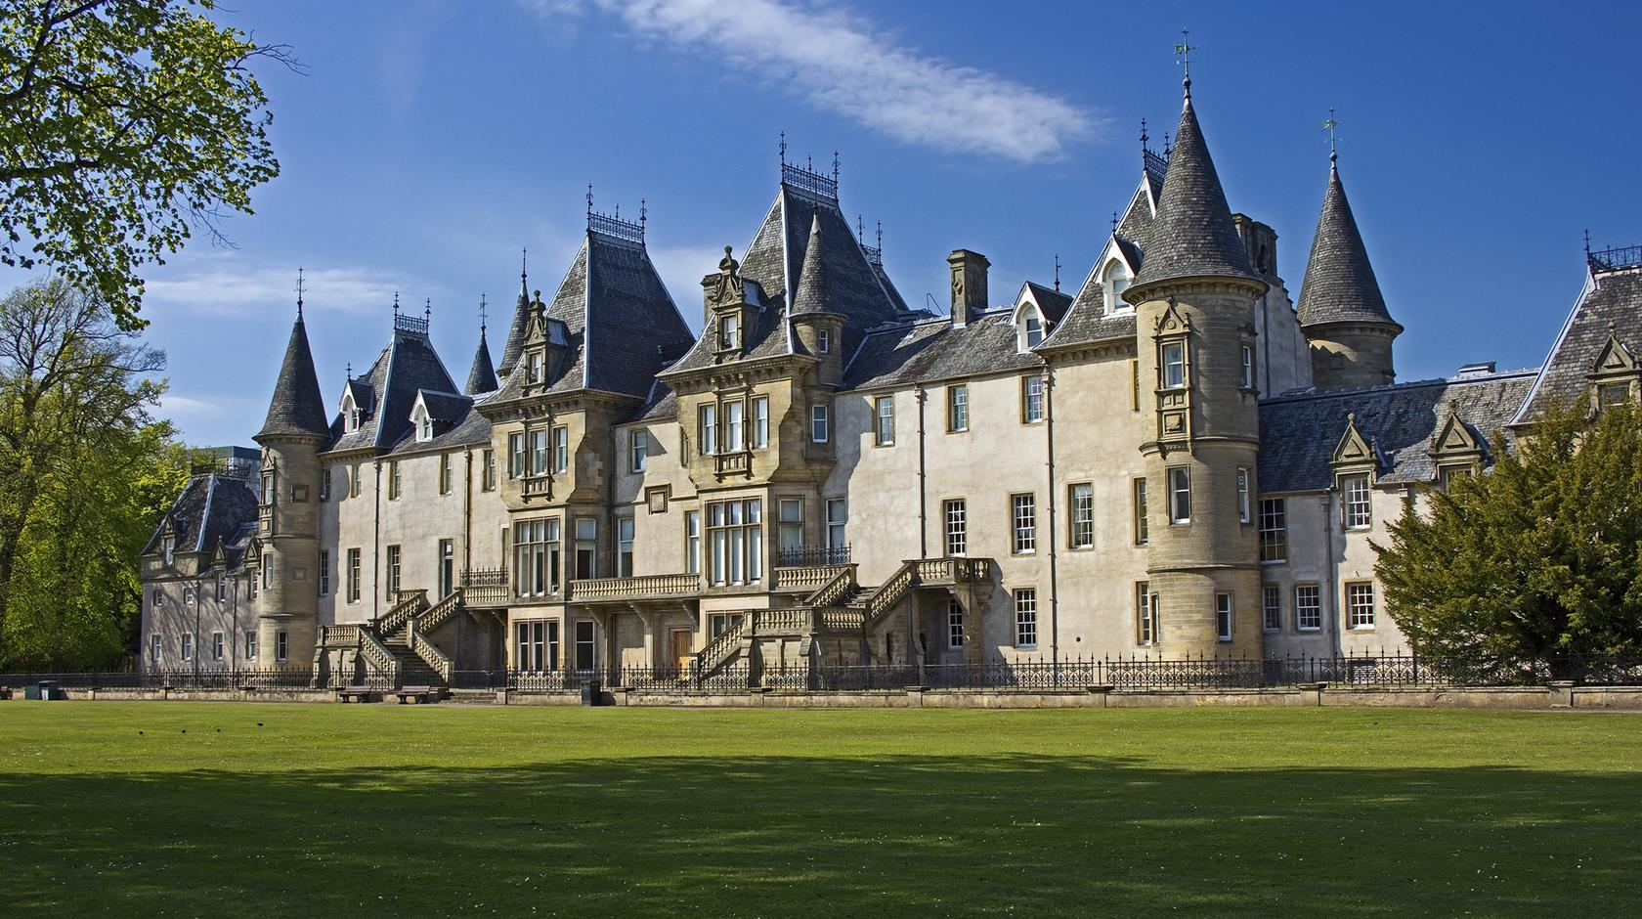

In 1783 the estate went to auction after the York Buildings Company was forced to sell its assets. Lord Errol bid for the estate, but was outbid by an Aberdeen coppersmith William Forbes (1756–1823), a businessman who specialised in contracts to supply the Royal Navy. William Forbes bought the house and estate for £100,000, though it was rumoured at the time that the timber alone on the estate was worth double that. Forbes made significant alterations to the house, and his son and grandson further altered the building by adding French-château-style roofs.
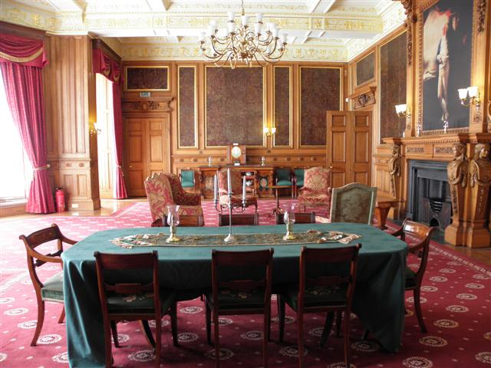

In 1827 a scheme of internal alterations was undertaken, to designs by David Hamilton. Forbes' descendants kept the house for almost 200 years, after which it fell into disrepair. When construction of the Union Canal was proposed, William Forbes objected to it passing through his estate, in view of Callendar House. This necessitated building a 696 yd (636 m) tunnel through Prospect Hill to the west. In July 2011, Falkirk Community Trust assumed responsibility for the management and operation of Callendar House.
In 1963 Callendar House was purchased along with some of the parkland by Falkirk Burgh Council. Since 2011 Callendar House has been administered through Falkirk Community Trust. The majority of the estate is still owned by the family company Callendar Estate, which remains the largest landowner in Falkirk.

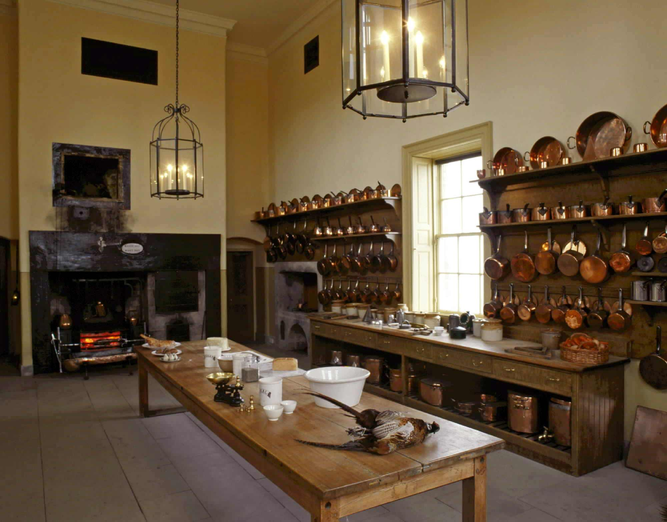
Corgarff Castle
Location: Corgarff, Aberdeenshire, Scotland. Status: Owned by Historic Environment Scotland
Corgarff Castle is located at Corgarff, in Aberdeenshire, north-east Scotland. It stands by the Lecht road, which crosses the pass between Strathdon and Tomintoul. The castle was built in the mid 16th century by the Forbes of Towie. In 1571 it was burned by their enemy, Adam Gordon of Auchindoun, resulting in the deaths of Lady Forbes, her children, and numerous others, and giving rise to the ballad Edom o Gordon.

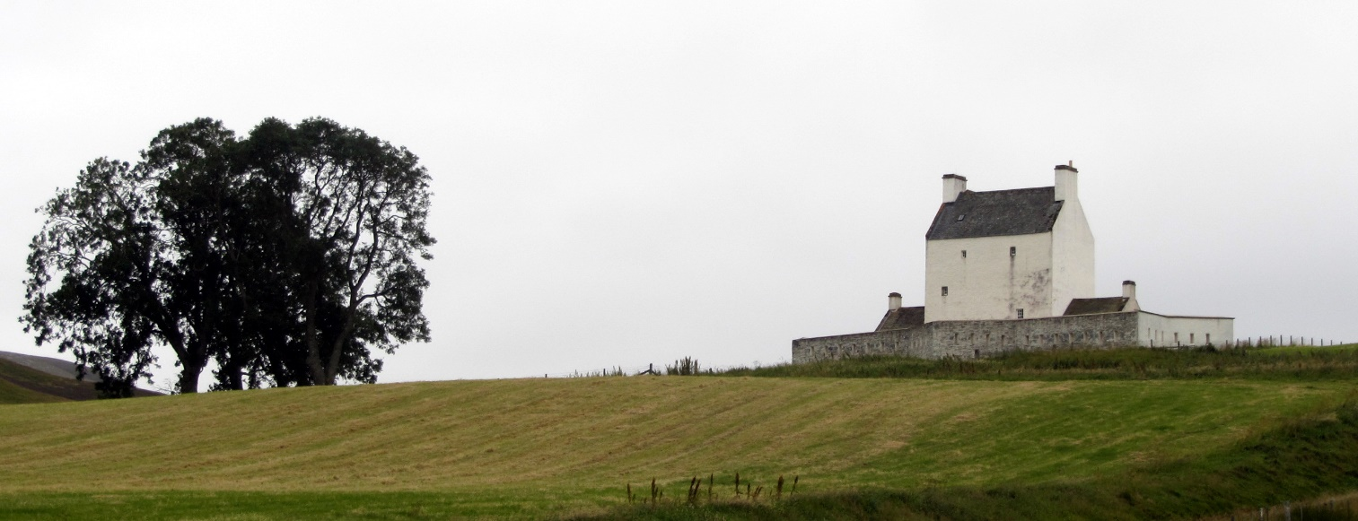

After the Jacobite risings of the 18th century, it was rebuilt as a barracks and a detachment of government troops were stationed there, on the military road from Braemar Castle to Fort George, Inverness. Military use continued as late as 1831, after which the tower served as a distillery and housed local workers. It remained part of the Delnadamph estate belonging to the Stockdale family until they passed the castle into state care in 1961 and gave the ownership of the castle to the Lonach Highland and Friendly Society. It is now in the care of Historic Scotland and is open to the public.

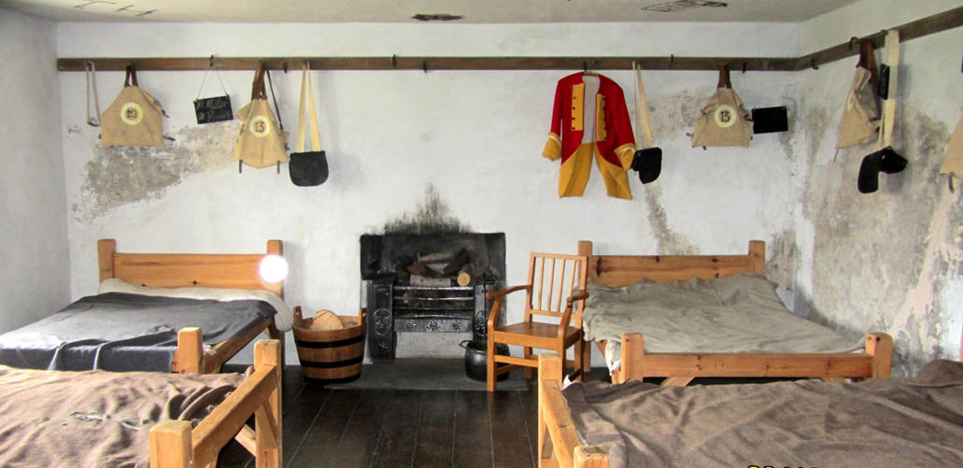

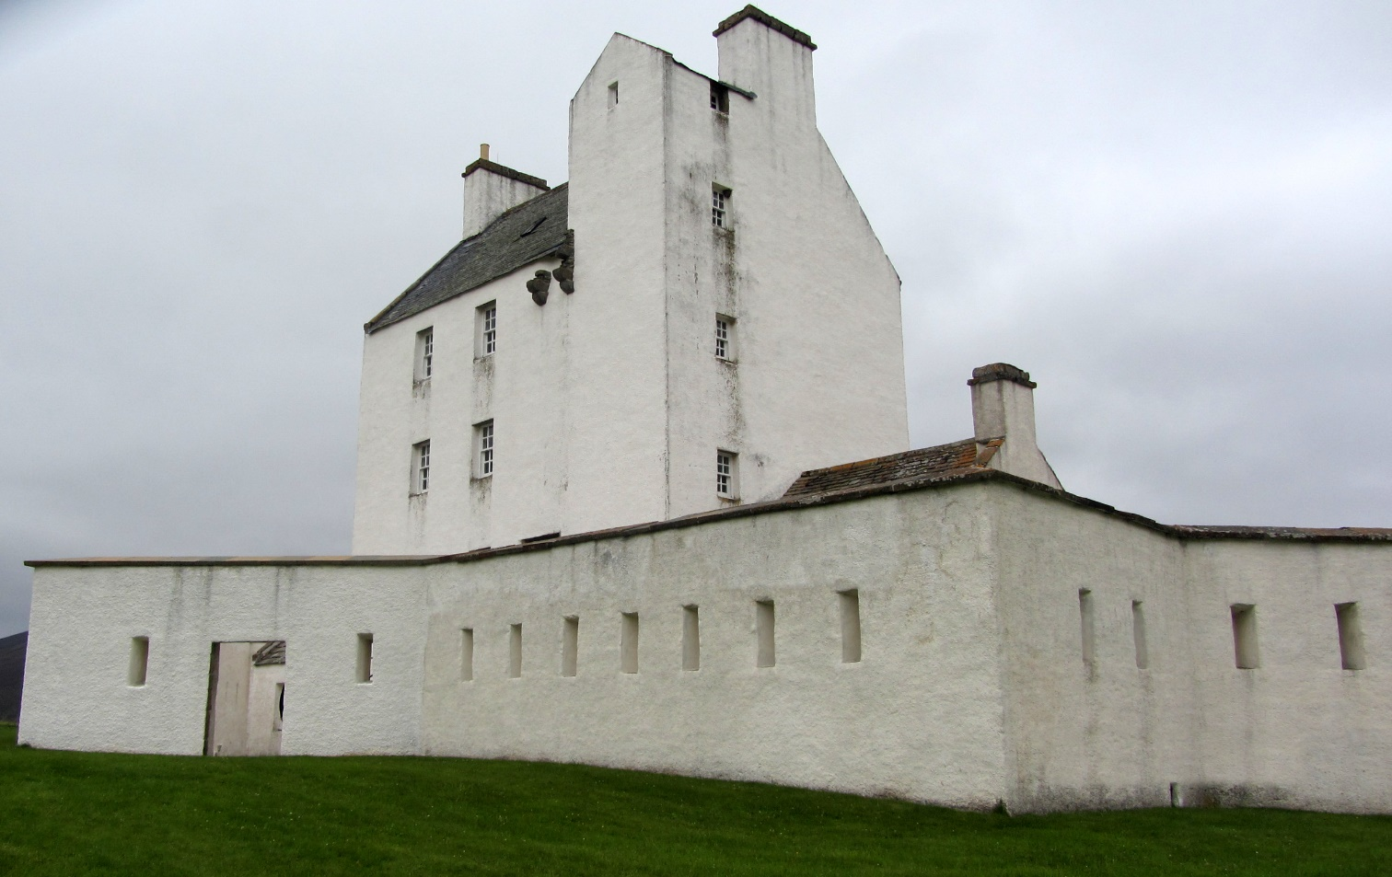
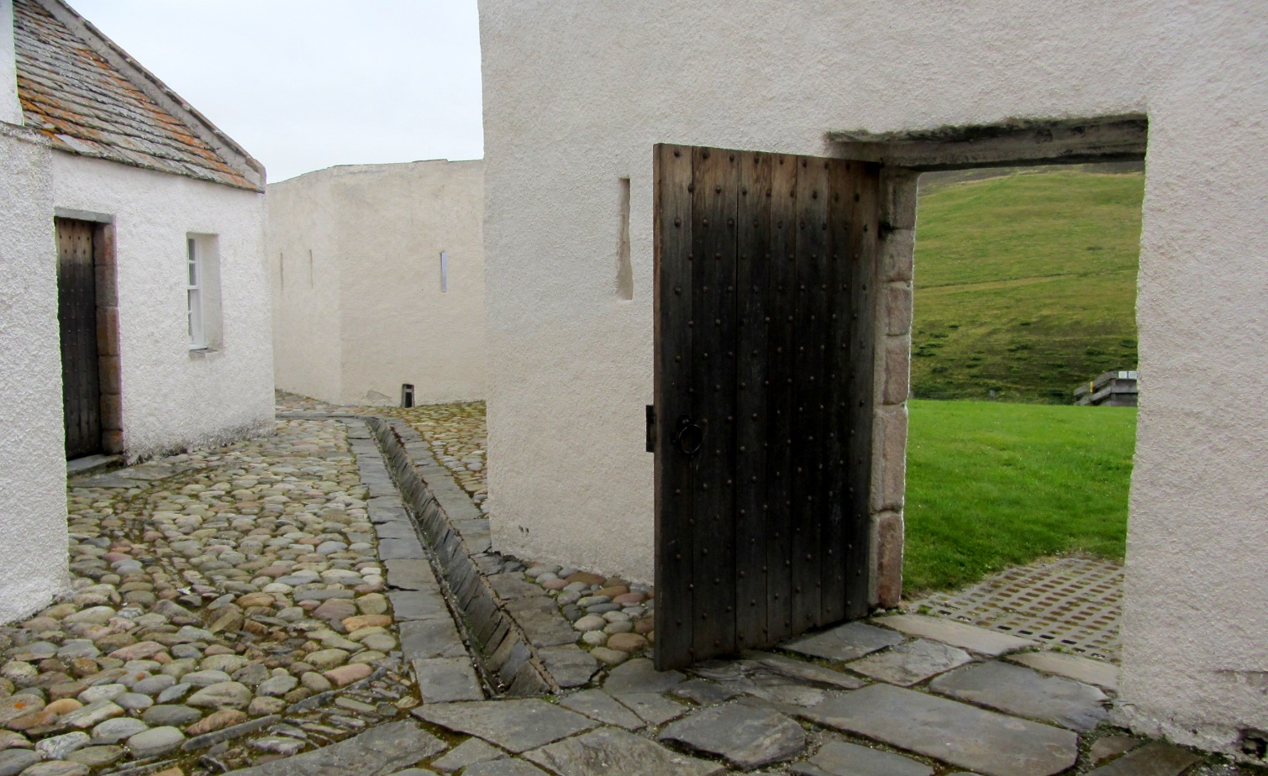

Corse Castle
Location: Lumphanan, Aberdeenshire, Scotland. Status: Open by Appointment.
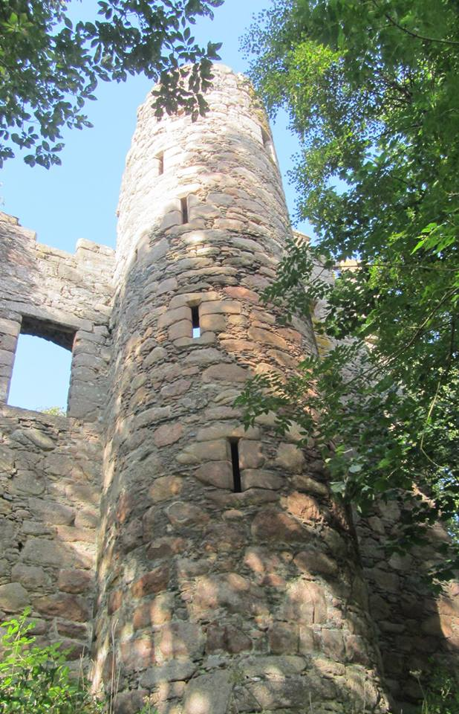
Corse Castle near Lumphanan in Aberdeenshire, now ruined, was a fortress and center of a landed estate in the northeast of Scotland. The castle stands by the Corse Burn, about 3.1 miles northwest of Lumphanan. Corse was a property of the Forbes family. In the 16th century the original house on the site was destroyed by bandits in a raid. The laird of the day, Sir William Forbes, is reputed to have said of his projected new castle "Please God I will build me such a house as thieves will need to knock at ere they enter." The present castle was subsequently erected by William, and bears his initials with the date 1581. William Forbes had seven sons, of whom the eldest, Patrick (1564–1635), was born at the castle before the rebuilding. In 1618 he was appointed Bishop of Aberdeen, serving until his death. The second son, William, a merchant, bought and completed nearby Craigievar Castle in the 1620s. The third son John Forbes (c.1565–1634) also entered the church. The sixth son, Arthur, settled in Ireland and was created a baronet. Patrick's second son, theologian John Forbes (1593–1648), inherited Corse in 1635, and died there in 1648, having opposed the National Covenant and been exiled for three years.

In The Castellated and Domestic Architecture of Scotland (1887), David MacGibbon and Thomas Ross say: This ruinous castle is pleasantly situated in a retired locality about three miles north from Lumphanan Station on the Deeside Railway. The Corse Burn, which runs through the hollow adjoining, has been dammed up, and forms a fine sheet of water to the south of the castle... The property has long belonged to the Forbeses, and the present building was erected in 1581 by William Forbes, the father of Patrick, the well-known Bishop of Aberdeen. The date and his initials are on the lintel of the entrance doorway. The current owner is Sir Andrew Iain Forbes, 13th Baronet, of Winds'eye Farm.

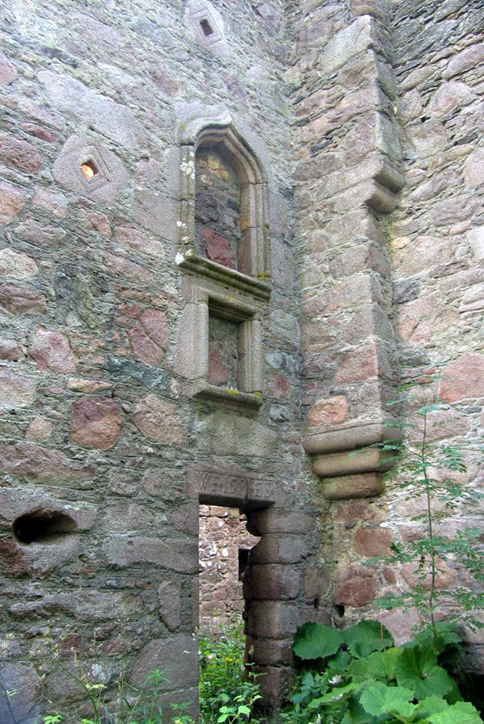
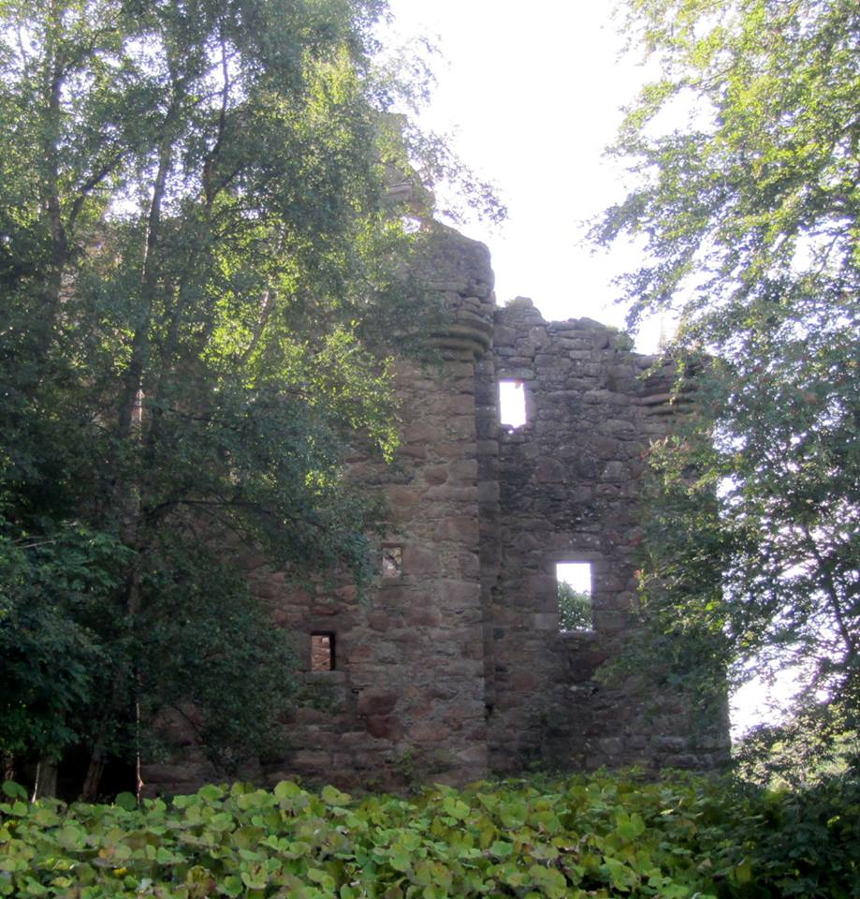

Craigievar Castle
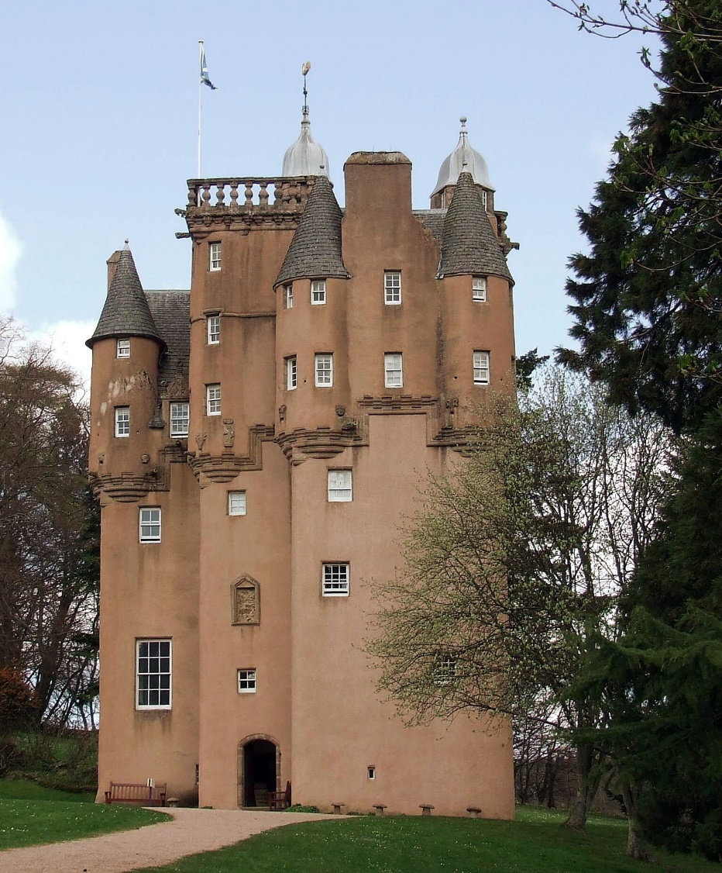
Location: Corsindae, Aberdeenshire, Scotland. Status: Open to the Public. Owned by National Trust for Scotland
An excellent example of the original Scottish Baronial architecture, the great seven-storey castle was completed in 1626 by the Aberdonian merchant William Forbes, ancestor to the "Forbes-Sempill family" and brother of the Bishop of Aberdeen, Patrick of Corse. Forbes purchased the partially completed structure from the impoverished Mortimer family in the year 1610. By the early 19th-century, the tower had fallen into decay.
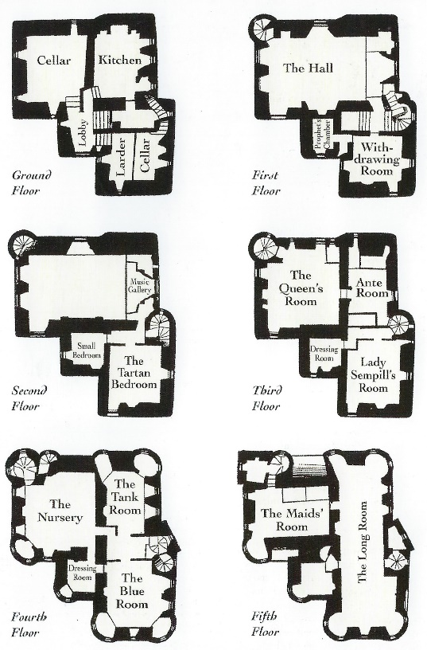
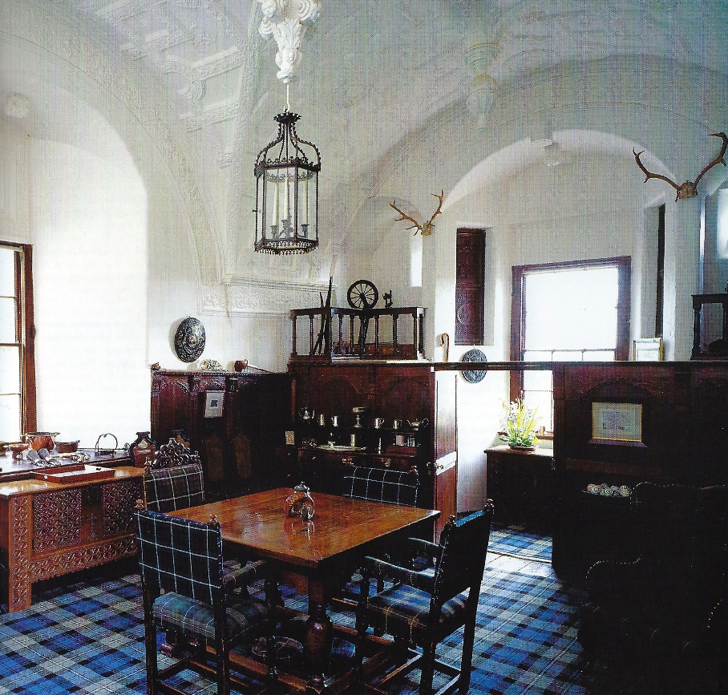

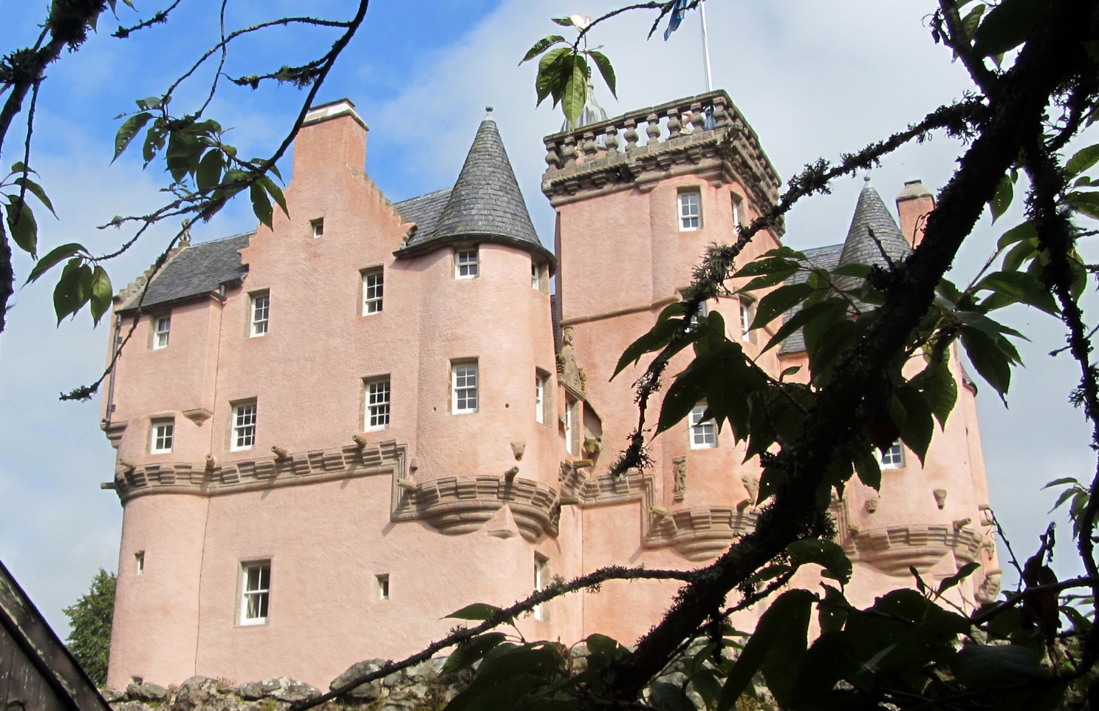
Sir John Forbes had considered demolishing the tower and consulted the Aberdeen city architect John Smith who advised against that course of action, stating the tower was: "one of the finest specimens in the Country of the age and style in which it was built." The castle originally had more defensive elements including a walled courtyard with four round towers; only one of the round towers remains today. The castle interior boasts a Great Hall that has the Stuart Arms over the fireplace; a musicians gallery; secret staircase connecting the high tower to the Great Hall; Queen's Bedroom; servants' quarters and of course several splendid plasterwork ceilings. There is a collection of Forbes family portraits inside as well as a considerable quantity of Forbes furnishings dating to the 17th and 18th centuries. The castle also houses two original Henry Raeburn portraits complete with original receipts. The castle is reputed to have been the inspiration for Walt Disney's castle motif.
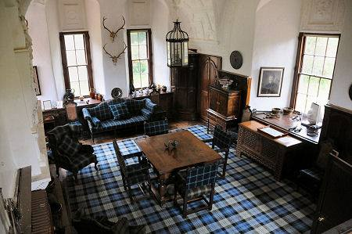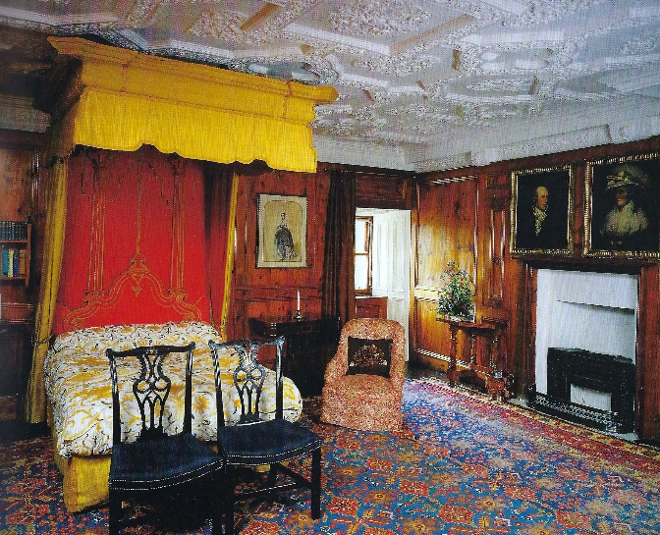

Culloden House
Location: Culloden, Inverness-shire, Scotland. Status: Hotel. Open to the Public.
Culloden House, a Georgian mansion set in open parkland. The existing house, over 200 years old, is not the first house to stand on the site. Originally it was a 16th century Jacobean castle and parts of the house date back to this time. Early on various owners claimed Culloden as their home ranging from the family of the first Stuart King, Robert II, to the chieftain of the Macintosh clan. In 1625 Duncan Forbes purchased Culloden from the Macintosh chieftain and the Forbes family began their nearly 300 year history with it. Descended from the Forbes of Tolquhoun on his father’s side, and of the Keiths, Earls Marischal on his mother’s, he was a clear example of a wealthy urban merchant leaving trade to set his family up as land owners and lairds.

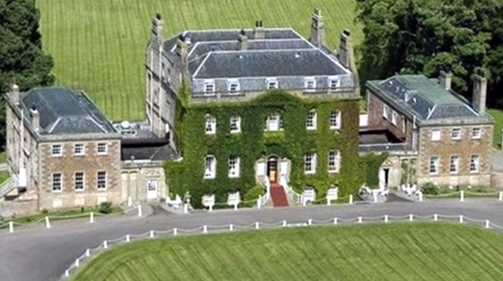

The most famous Forbes of all, another Duncan inherited the lands from his older brother John and moved into Culloden House. Duncan was Lord Chief Justice of Scotland at the time of the 1745 Jacobite Uprising. As staunch Presbyterians, the family had suffered during earlier Jacobite uprisings, including having the house occupied and plundered by Viscount Dundee in 1688. Duncan convinced some powerful Highland chiefs not to join the ’45 uprising. Duncan, however, was appalled by the aftermath of the battle and urged George II not to inflict harsh punishment on the Highlanders. But George II was shaken by the rebellion and not in the mood to listen. He angrily responded to Duncan’s pleas by withholding payment of funds owed Duncan by the crown, nearly ruining his fortune. Duncan died a few years after the battle, it is said, of a broken heart. It was left to later Forbes to rebuild the family fortune and create the beautiful house we know today.
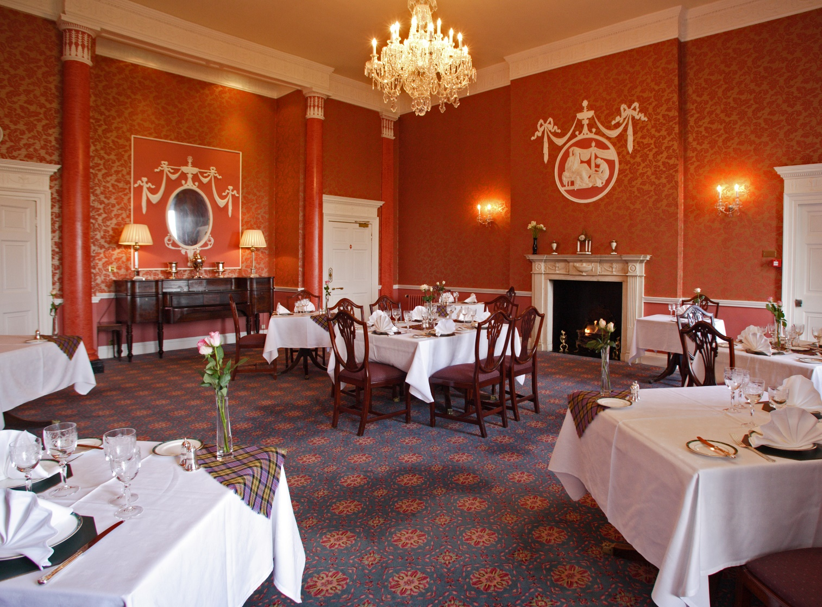

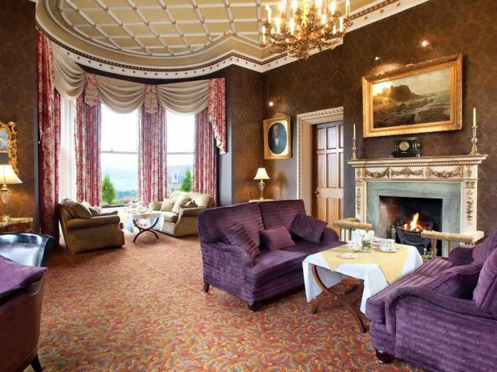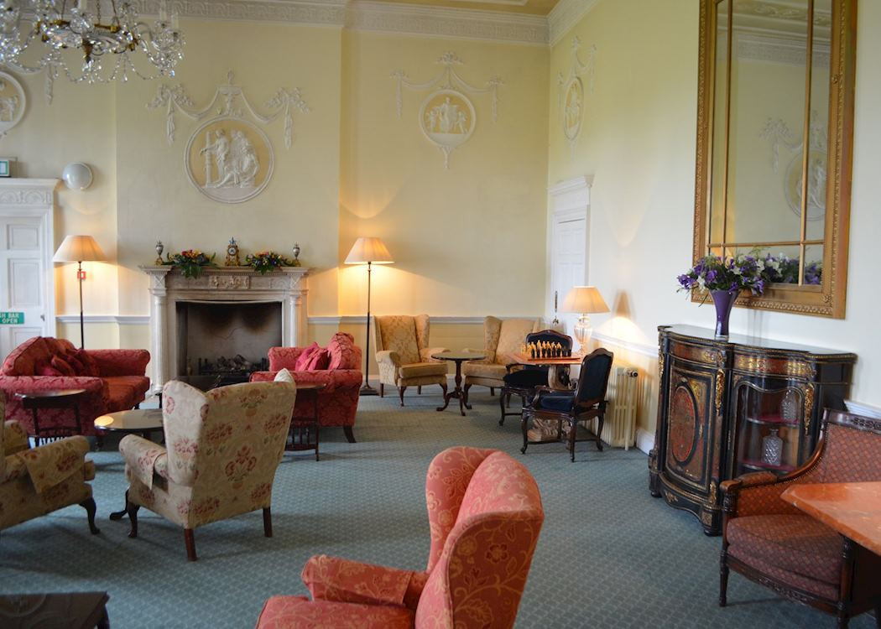

Ellon Castle
Location: Ellon, Aberdeenshire, Scotland. Status: Open to the Public.
Ellon Castle is a scheduled monument within the town of Ellon, Aberdeenshire. Only ruins survive of the 16th-century structure that may incorporate sections from the 15th century together with 18th-century renovations. Land known as the Hill of Ardgith was sold by Isobel Moffat to Thomas Kennedy in 1413. Kennedy – sometimes spelt as Kynidy – had been appointed as hereditary Constable of Aberdeen by the Duke of Albany in appreciation for his actions during the Battle of Harlaw. A fortification was constructed at some point after the purchase date of the land and before 1500; originally known as the Fortalice of Ardgith, the castle was likely built by the Kennedy of Kermuck – sometimes recorded as Kinmuck – family and was used as their family seat. According to the archaeology historian W. Douglas Simpson the basement vault dates to the 15th century and pre-dates any later remains. The castle was reconstructed in the late 16th century that, according to Simpson, was undertaken by the masons John and Thomas Leiper, who were also responsible for work at nearby Tolquhon Castle, the House of Schivas and Castle Fraser. A stone bearing the Kennedy arms is set into the ruins. Dated 1635, the marriage stone pictures a shield and bears the initials G. K. The ruins form a focal point in a formal 6-acre garden planted in 1745. A sundial dating from about 1700 forms the centrepiece to the garden. It may have been erected as a memorial to Baillie Gordon of Ellon's two children who were murdered by their tutor, Robert Irvine, in 1717. The gardens are now owned by the Scottish Charity, Ellon Castle Gardens.
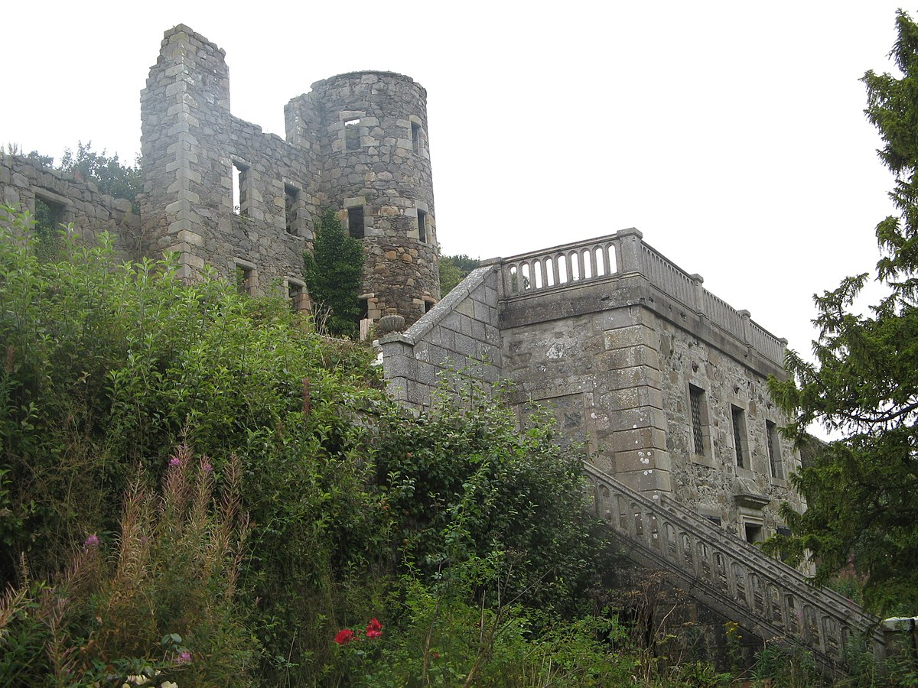

Pitsligo Castle & Kirks
Location: Rosehearty, Aberdeenshire, Scotland. Status: Open to the Public. Owned by the Pitsligo Castle Trust.
Pitsligo Castle originated as a 15th-century keep built around 1424 by the Fraser family of Philorth. Ownership later passed to the Forbes family of Druminnor and they extended the castle to its current layout. In 1633 Alexander, the 8th laird, was named Lord Forbes of Pitsligo by an Act of Parliament. Lord Forbes built the nearby kirk, with a wonderful laird's loft over a family burial vault. In 1635 he turned his attention to the castle, greatly enlarging the medieval tower with ranges of buildings around a courtyard. The 2nd Lord finished his father's work, creating a luxurious residence with opulent interiors. Every window was glazed - a measure of just how much wealth the laird lavished on his new home, with became one of the finest residences in north-east Scotland.
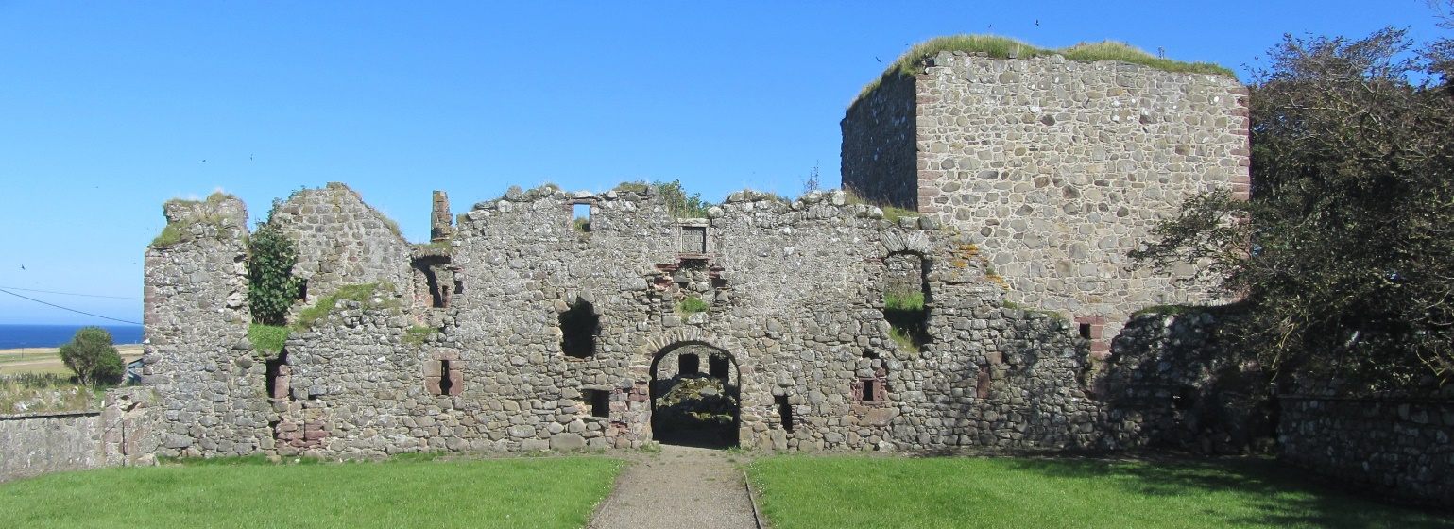

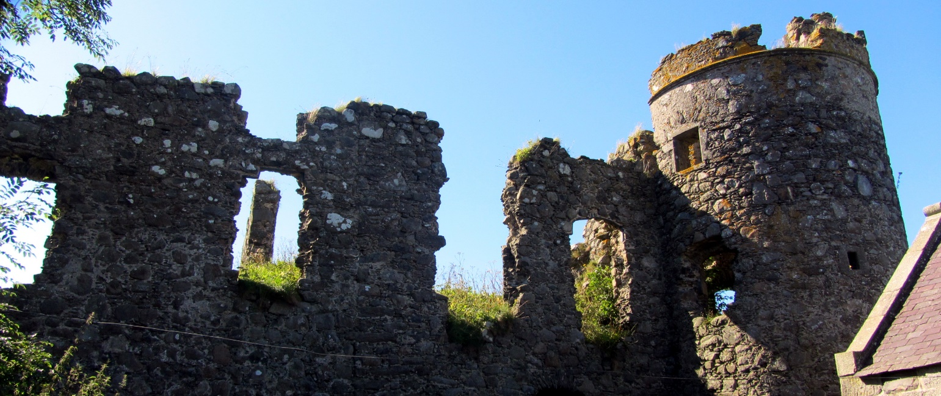

Like so many historic houses in the area, the fate of Pitsligo hung in the balance during the Jacobite uprisings in the 18th century. The last Forbes of Pitsligo, another Alexander, supported both the '15 Rising and Bonnie Prince Charlie's 1745 rebellion. After the Stuart defeat at Culloden, Forbes was forced to flee for his life. He was declared an outlaw, with a price on his head, but though he lived on the run until his death by natural causes in 1762, he was never betrayed to the government soldiers who sought him. Unfortunately, while Fraser was an outlaw Pitsligo was seized by the crown. The castle was sacked by King George's troops, and allowed to decay, becoming little more than a crumbling ruin.

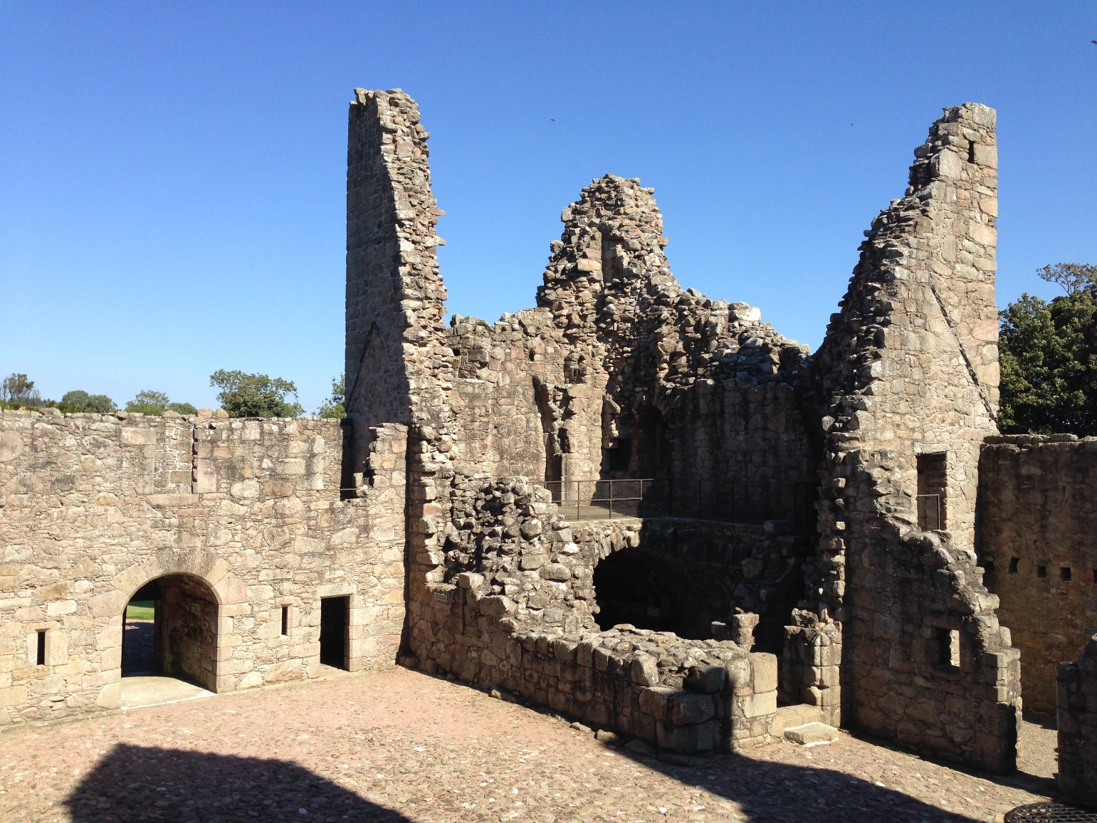

Then in 1989 a descendant, publishing magnate Malcolm Forbes, purchased the castle estate and restored the fortress - if not to its former grandeur, at least to the point where it was no longer in danger of falling down. After Forbes died in 1995 the castle passed to the Pitsligo Castle Trust, a charity group who also maintain the historic kirk nearby and are developing a Scottish Heraldry Centre and Jacobite museum.
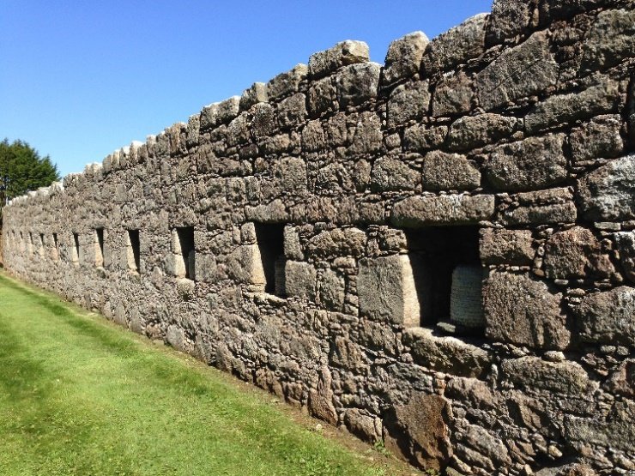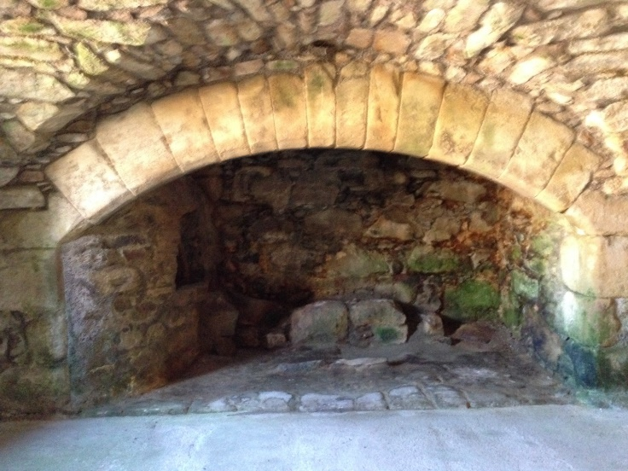

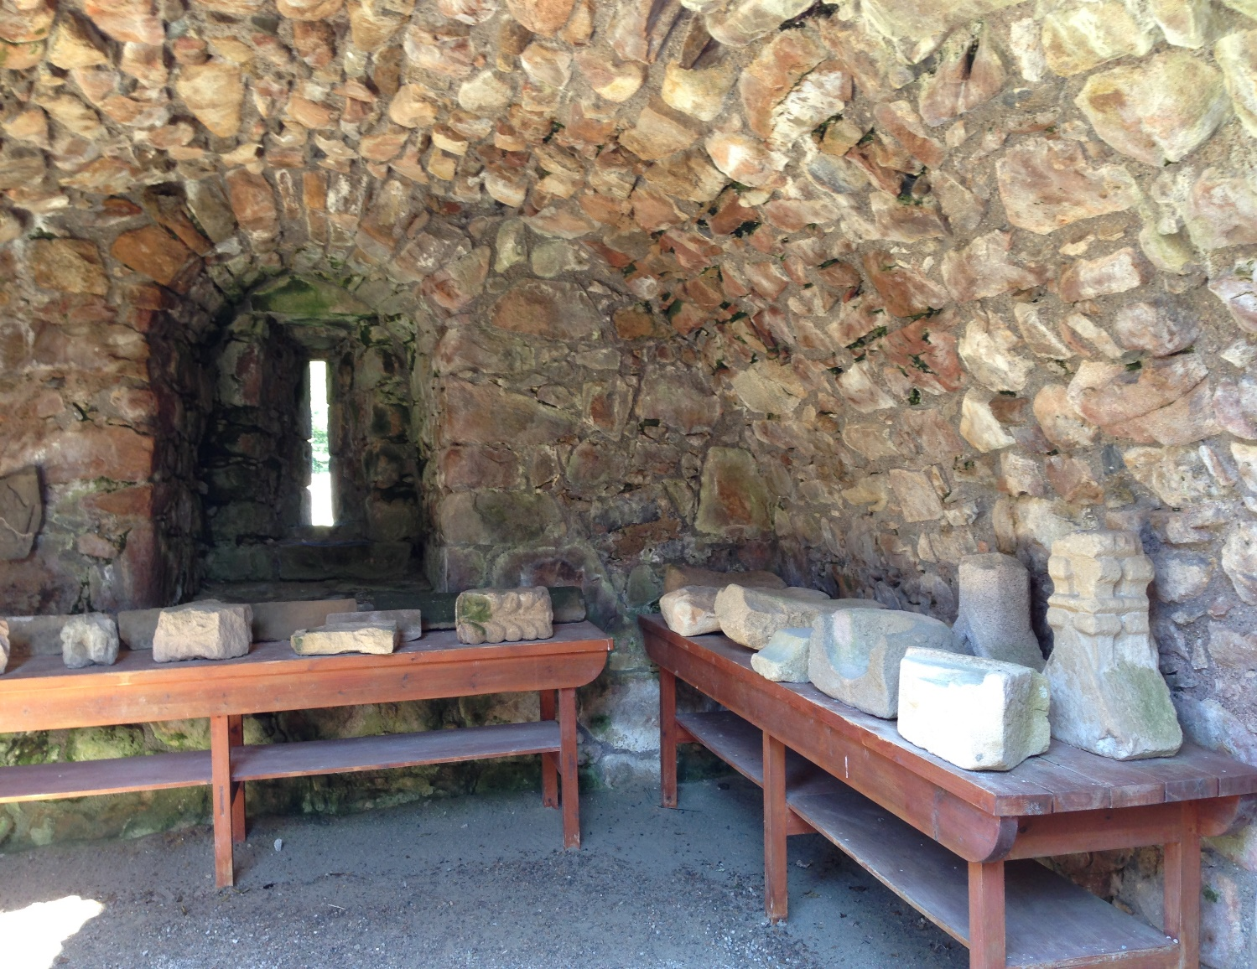

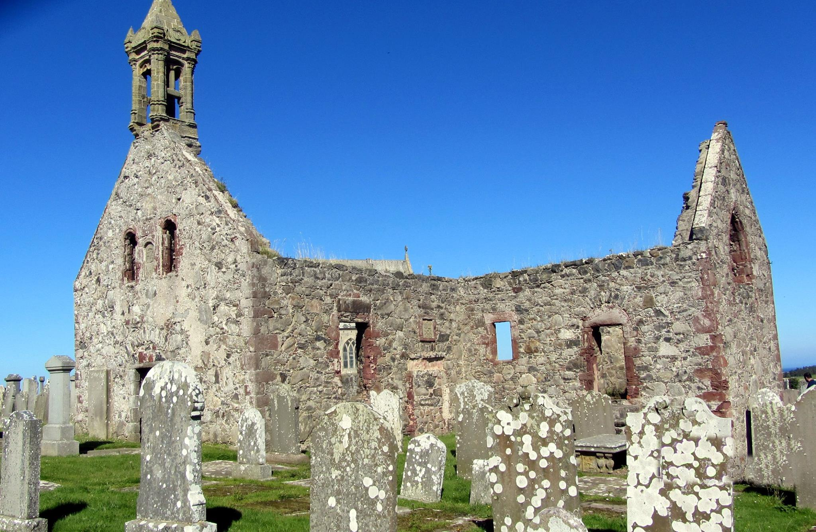

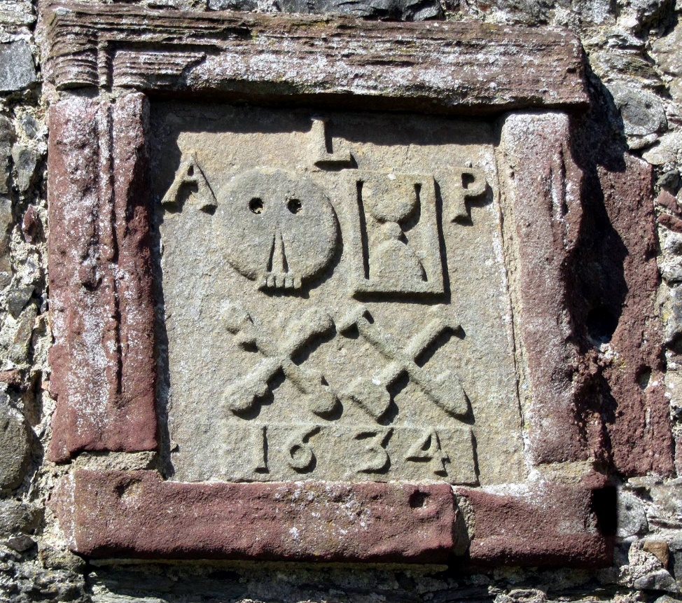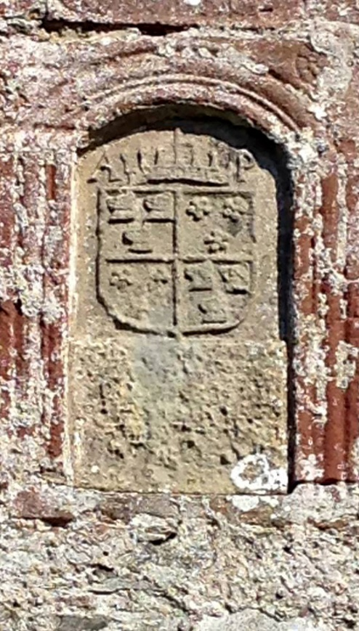
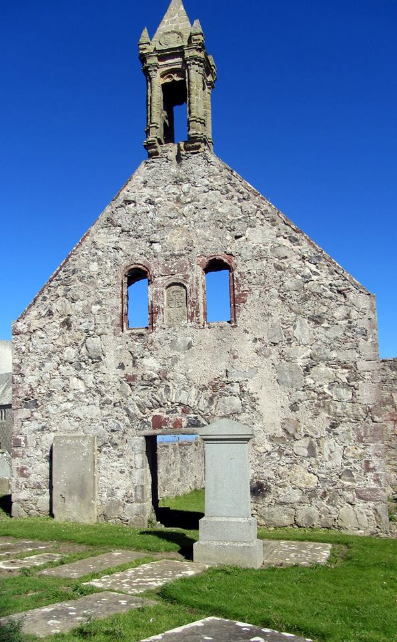
Thainstone House
Location: Inverurie, Aberdeenshire, Scotland. Status: Open to the Public. Hotel.
In the 18th Century, the Jacobites torched the original Thainstone House. However, James Wilson of Thainstone escaped the fire and fled to America where he later put his name to the American Declaration of Independence. Under new ownership in the 19th century, the architect Archibald Simpson extended the House in 1840 and it was further extended in 1992. Simpson was responsible for shaping much of the present-day city of Aberdeen.

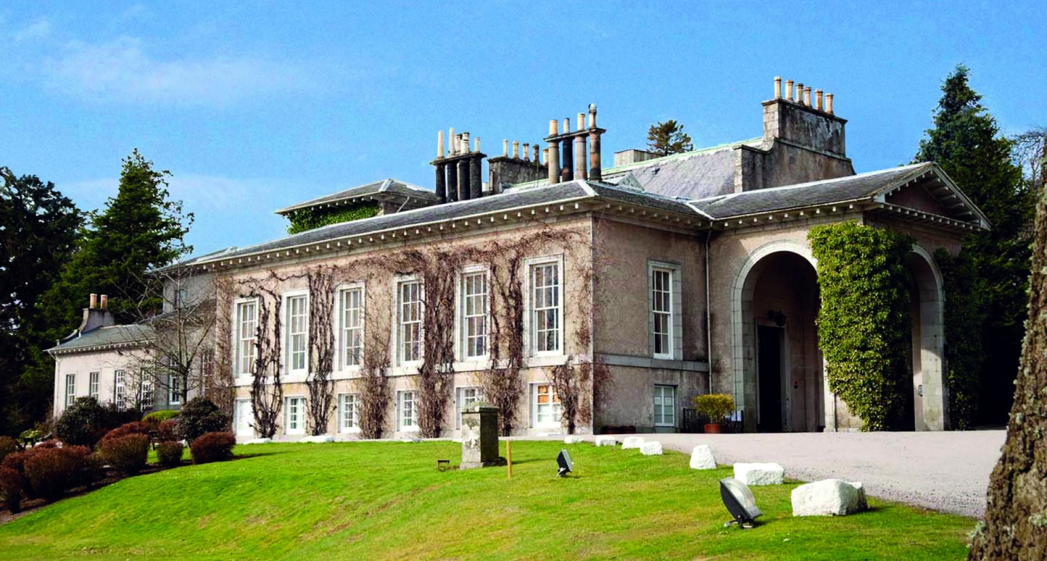
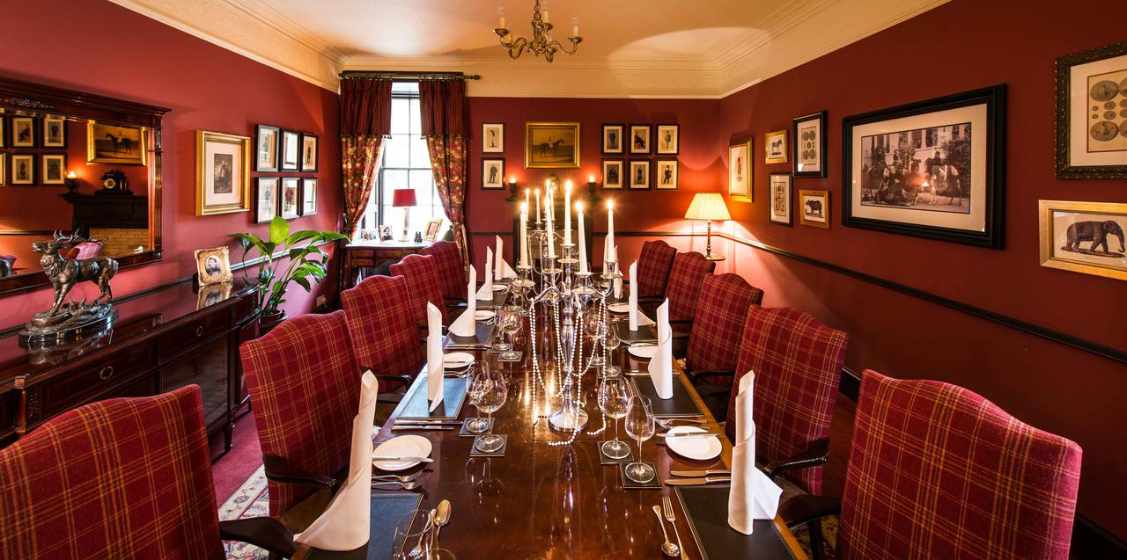
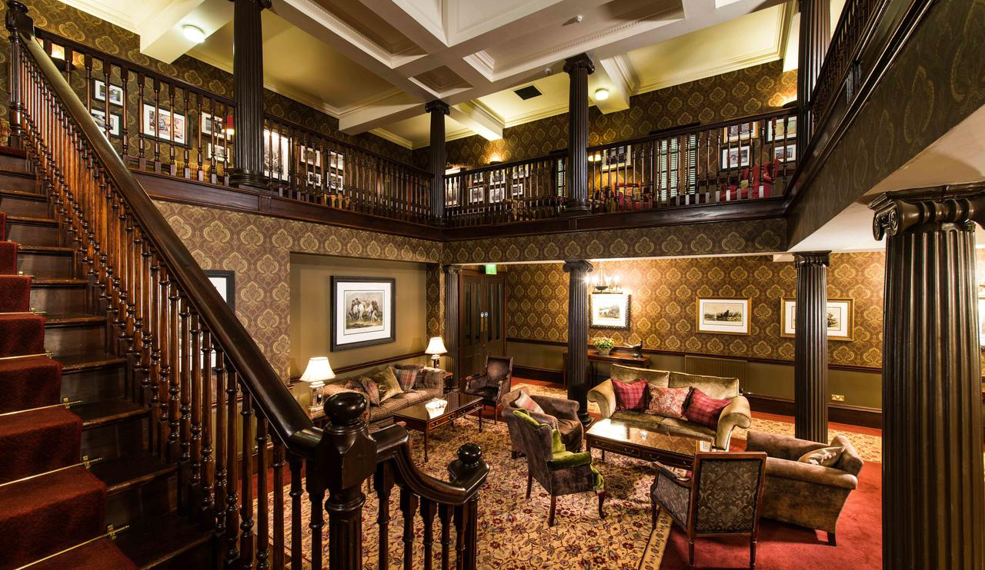

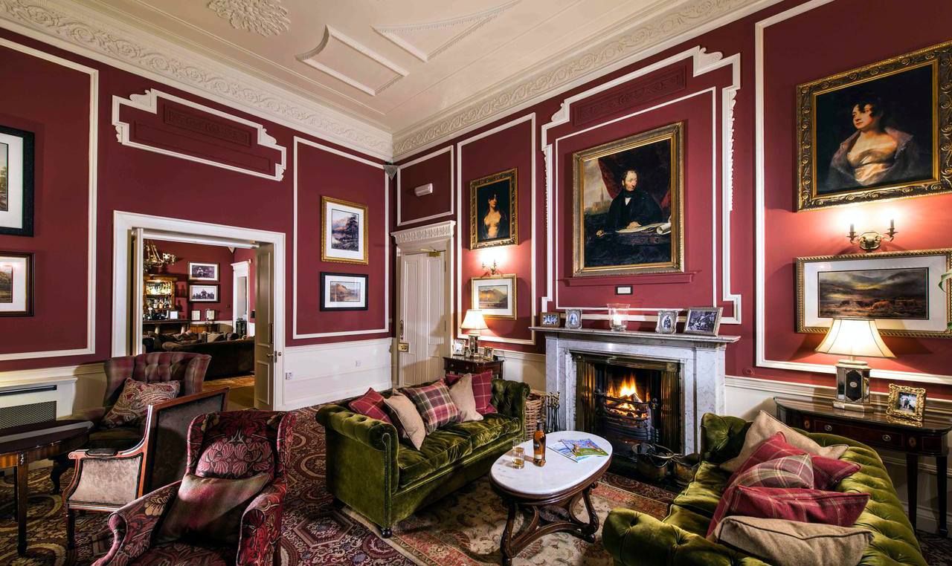

Tolquhon Castle
Location: Tarves, Aberdeenshire, Scotland. Status: Owned by Historic Environment Scotland. Entry fee.
Tolquhon Castle (pronounced: "toh-hon") was built by William Forbes, 7th Laird of Tolquhon, between 1584 and 1589 as an extension to the earlier tower house known as Preston's Tower.
Preston's Tower was constructed in the early 15th century, either by Sir Henry Preston or by his son-in-law Sir John Forbes, who inherited part of the Preston lands in 1420, following Sir Henry's death. His descendant William Forbes, 7th Laird of Tolquhon (died 1596), began work on a new castle in 1584, retaining the Preston Tower but adding new, more comfortable accommodation. He also improved the gardens and parkland around the house. King James VI was entertained at Tolquhon in 1589.

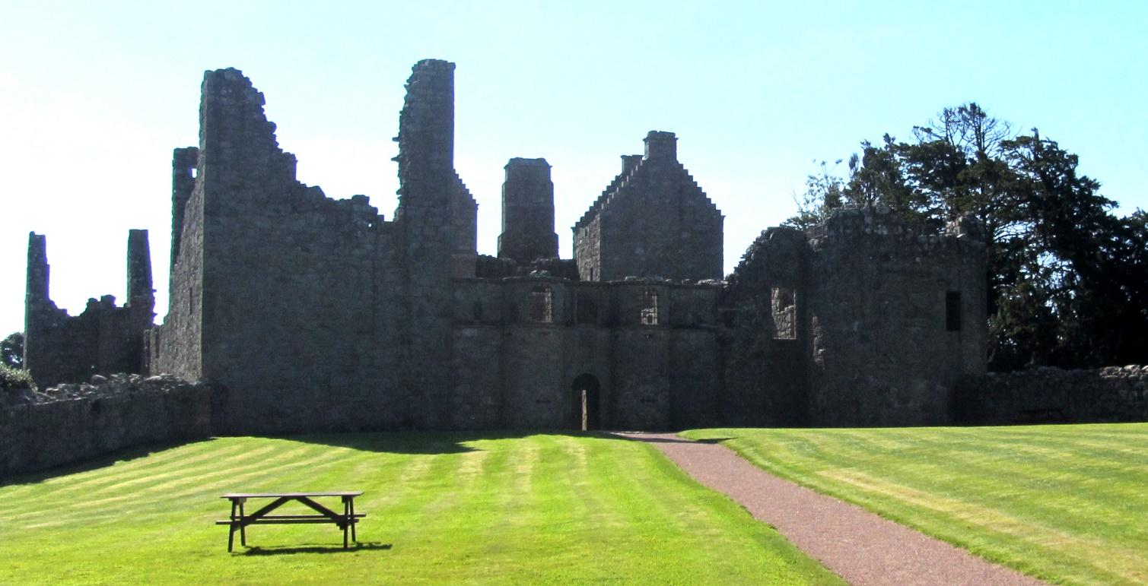

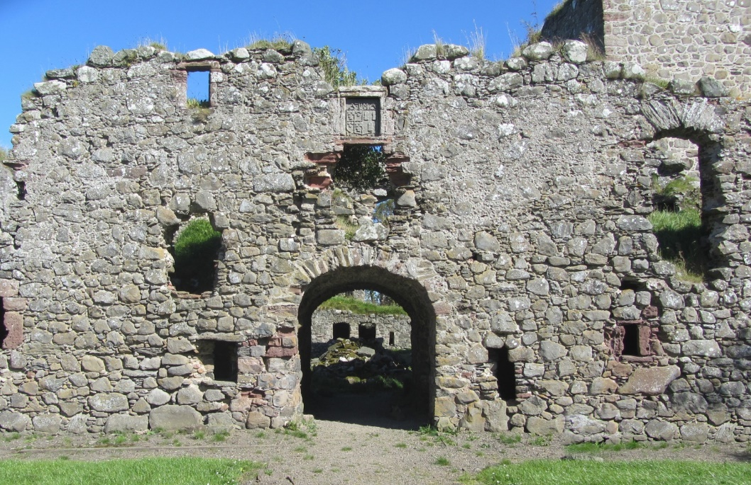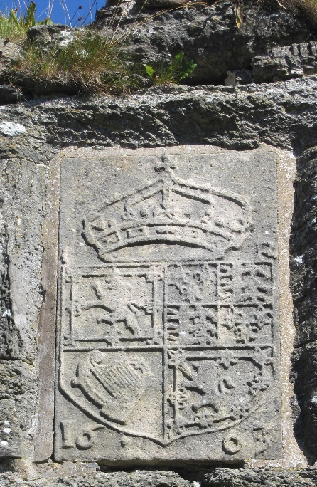

The new buildings were arranged around a courtyard, and included an elaborate gatehouse, and a first-floor gallery. The home of a "Renaissance man", Tolquhon was designed for show rather than defence, and was the work of the mason-architect Thomas Leper or Leiper. Leper's distinctive triple shot-holes flank the main entrance. Also unusual is the stone tilework in the main hall.

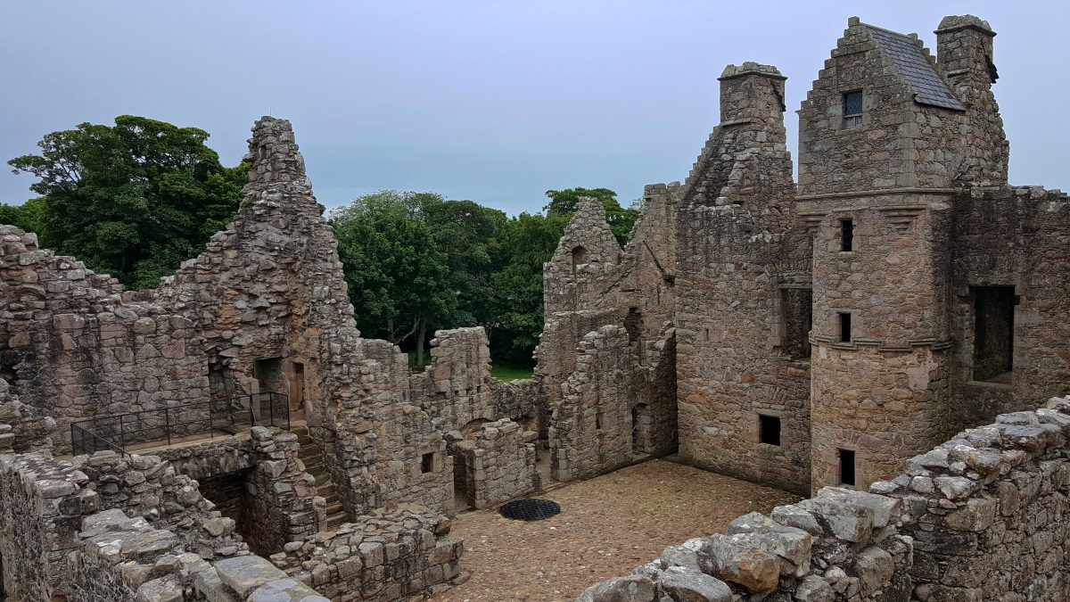

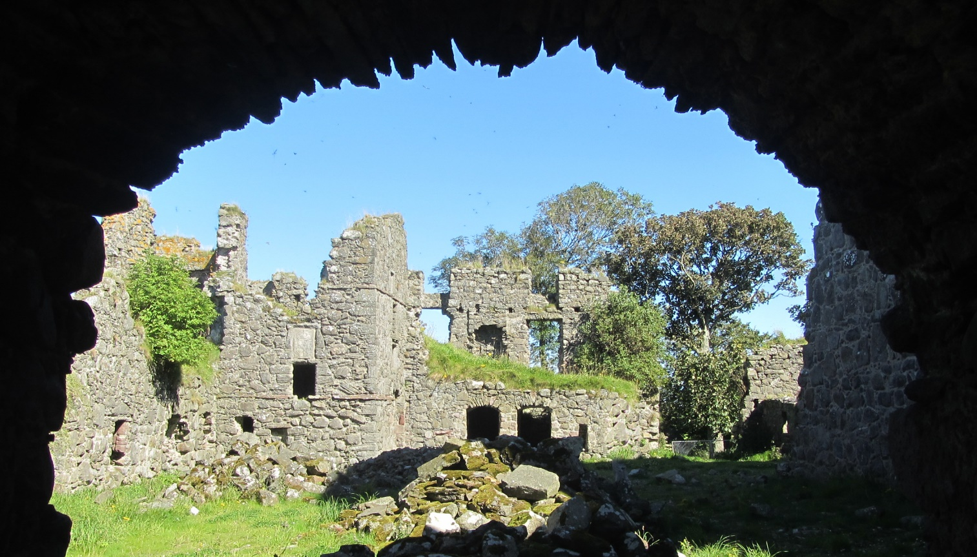
Plan Your Visit

Druminnor Castle. Tours are by appoint only. Please contact Alex Forbes at AlexDForbes@hotmail.com. Contribution to the Pitsligo Castle Trust and the Friends of Pitsligo Castle requested.
Castle Forbes. Overnight accommodations, fishing excursions, and tours are by appoint only. Please contact the Castle Forbes Estate Office at 019755 62524 or office@castle-forbes.com. For information on the Cothiemuir Hill Natural Burial Ground please visit www.aberdeennaturalburials.co.uk or telephone 08454 500 65.
Callendar House. Open to the public. Free parking. Groups of 10 or more must book in advance and may include brunch, lunch and high tea as part of the visit. For group visits, please call 01324 5033796 or 503787. For reservations for tea, please call box office on 01324 506850. Falkirk Community Trust, Suite 1A, The Falkirk Stadium, 4 Stadium Way, Falkirk, FK2 9EE.
Corgarff Castle. The castle is open April through September, daily from 9:30 AM to 5:30 PM. Entry fee required. For more information about Historic Environment Scotland, please visit www.historicenvironment.scot.
Corse Castle. Tours are by appointment only. Contact Clan Chief: mobile +44 (0) 7803 128 510, telephone +44 131 531 9482 or e-mail jamiesempill@gmail.com.
Craigievar Castle. Open to the public. Open generally April through September, from 10:30 AM to 4:00 PM. For specific dates and times, please visit website, noted below. Access by guided tours only, on a first come, first served basis with a maximum of 10 on each tour. Tours run approximately every 30 minutes. Entry fees are £13.00 per adult with other rates available. Admission is free for members of the National Trust for Scotland. For more information, email craigievarcastle@nts.org.uk or telephone 01339 883635. For more information about the National Trust for Scotland, please visit www.nts.org.uk.
Culloden House. Room reservations and rates are available online at www.cullodenhouse.co.uk. For reservations for dinner, afternoon tea or whisky tastings, please call 24 hours in advance by calling 01463 790461 or email info@cullodenhouse.co.uk. The hotel is owned by North American Country Inns, a syndicate of US investors based in San Francisco. Culloden Battlefield is open to the public throughout the year. The Visitor Centre is generally open except days around Christmas and New Year’s Day, from 10:00 AM to 5:00 PM. For specific dates and times, please visit website, noted below. Entry fees are £11.00 per adult with other rates available. Admission is free for members of the National Trust for Scotland. For more information about the National Trust for Scotland, please visit www.nts.org.uk.
Ellon Castle. The ruined castle is a “scheduled monument” and is open to the public. The gardens are owned and managed by Ellon Castle Gardens. The gardens are generally closed for safety reasons. However the trust offers “open days” throughout the year when members of the public can visit the site. Private viewings are available to groups by appointment. Contact via e-mail at info@elloncastlegardens.org or phone at 07495 675757. For more information about the gardens, please visit elloncastlegardens.org.
Pitsligo Castle & Kirks. The ruined castle and kirk are “scheduled monuments” and are open to the public. The Pitsligo Castle Trust and the Friends of Pitsligo Castle is raising funds for the restoration and preservation of the sites. For more information about Historic Environment Scotland, please visit www.historicenvironment.scot.
Thainstone House. Room reservations and rates are available online at www.crerarhotels.com/thainstone-house. Dining is available in the Club Room, Lounge and Gallery by day and The Green Lady restaurant or Stockman’s bar in the evening. Contact the hotel by telephone at 01467 621643 or via e-mail at thainstone@crerarhotels.com. The property is owned by Crerar Hotels, which owns and manages hotels throughout Scotland.
Tolquhon Castle. The castle is open April through September, daily from 9:30 AM to 5:30 PM. Entry fee required. For more information about Historic Environment Scotland, please visit www.historicenvironment.scot.

Acknowledgements

Photograph Credits. Druminnor Castle: B.R. Forbes; Castle Forbes: B.R. Forbes; Callendar House: by special permission of the Falkirk Burgh Council; Corgarff Castle: B.R. Forbes; Corse Castle: B.R. Forbes; Craigievar Castle: by special permission of the National Trust for Scotland; Culloden House: by permission of North American Country Inns; Ellon Castle: by special permission of the Ellon Castle Gardens; Pitsligo Castle & Kirk: B.R. Forbes; Thainstone House: by special permission of Crerar Hotels; and Tolquhon Castle: B.R. Forbes.

Specials Thanks.
- Malcolm, Lord Forbes, of Forbes Castle, Aberdeenshire, Scotland, for guidance and support.
- Alex Forbes of Druminnor Castle, Aberdeenshire, Scotland, for research of the House of Forbes Major Branches and overall editing.
- Barry Robert (Bart) Forbes of Virginia, U.S.A., for research, writing, editing and layout.
- Nancy Forbes of Virginia, U.S.A, for review and editing.

Copyright. © Clan Forbes Society, Inc.

